2023-24
A Guide to
Music
at
Carlinghow Academy

This document outlines the expectations of how we teach and monitor Music at Carlinghow Academy: progression across year groups and consistency across school. It should be read in conjunction with the Music section under learning on the website.

Intent
Carlinghow Academy’s curriculum is driven by the academy’s vision that all children ‘can and will succeed’.
We provide an ambitious knowledge engaged curriculum that offers exciting and meaningful learning opportunities that motivate and inspire.
The curriculum is underpinned by the National Curriculum and ensures that, at each stage of their learning journey, each child acquires a rich bank of knowledge and skills. This knowledge and these skills in all curriculum subjects are learned, practised, retrieved and remembered at every stage of their journey through school.
Our curriculum is not narrowed, we have designed an ambitious curriculum based on the knowledge of our learners that includes a high proportion of disadvantaged and SEND pupils to ensure that they are equipped with the knowledge and cultural capital they need to succeed in life. Where appropriate, a bespoke and highly personalised curriculum offer is made to individual pupils.
Our cross curriculum approach is designed so that subject specific skills are taught within an exciting topic each half term and enables our children to make meaningful links and become passionate about their own learning and wellbeing. Hooks, enrichment activities and extra-curricular opportunities supplement each topic to enable our children to make connections in their learning and acquire a deep understanding. We ensure that the links we make are real, not contrived and choose areas where genuine connections between subjects occur naturally. Ensuring that the connections make sense to the children.
We are determined that every child, will have a lifelong love of Music, and will be able to comprehend and utilise tier 2 and tier 3 vocabulary by the end of Year 6, ensuring all children have the opportunity to perform. Our curriculum is led by music express, which guides our knowledge around the subject.
We have created an environment where children are motivated to learn together in a respectful, safe and trusted learning environment where individual success are celebrated.
It is our intent that when our pupils leave school, they will articulate tier 3 vocabulary of the PSHCE curriculum. They will know and remember key learning of PSHCE from their primary years.

Implementation
The curriculum is based on good quality resources and an understanding of foundational knowledge that can be built throughout school. Musical instruments can be found at the back of the PE cupboard and should be used fluidly throughout the year.
This Music guide explains how the Music curriculum is implemented at Carlinghow Academy.
The school has adapted the curriculum to help reflect and represent the diversity of our pupils to ensure all children have the opportunity to learn. Creativity and teacher expertise, underpinned by high quality research informed CPD, is woven into the curriculum with specialist teachers and outside agencies working with pupils and teachers, sharing good practice and ensuring that learners learn from the best.

Impact
The impact of providing such an ambitious curriculum driven by the academy’s vision and values and taught by skilled teachers, ensures that the children of Carlinghow Academy leave prepared for the next stage of their education and able to succeed in life. Knowledge, understanding and skills are secured and embedded through flashbacks and performance opportunities, so that children attain highly. They take pride in all that they do, always striving to do their best. They demonstrate emotional resilience and the ability to persevere when they encounter challenge. They develop a sense of self-awareness and become confident in their own abilities. They are kind, respectful and honest, demonstrate inclusive attitudes and have a sense of their role in our wider society. They have strong communication skills, both written and verbal, and listen respectfully and with tolerance to the views of others. They take risks and are emotionally resilient recognising that we make mistakes and learn from them. They dream big and have high aspirations fostered by the belief that with determination and hard work anything is possible.
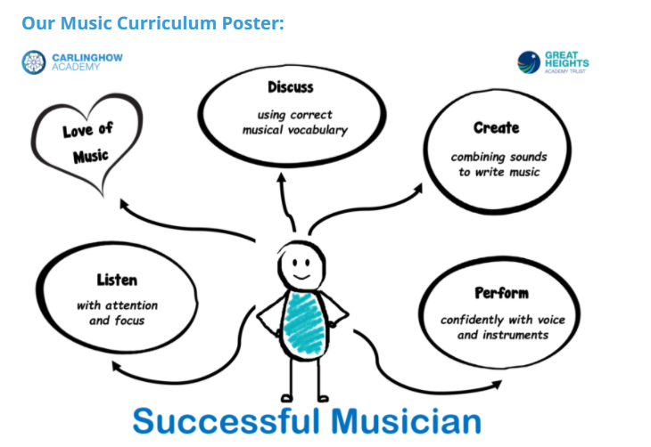
At Carlinghow Academy we teach Music through the Music Express programme alongside peripatetic music teachers and through assemblies.

Music Express provides everything teaching primary music, week by week. Written by leading experts in primary music education, Music Express has quality and engaging music lessons with careful progression built in, from Early Years to Age 11. It is easy to use for teachers with little confidence in music, and allows flexibility for music specialists. Although it should be noted that these lessons should always be adapted by the teacher to suit the needs and level of your class. Where Music is delivered by a peripatetic teacher, there is no need for a further Music session however care must be taken to ensure all objectives and skills are covered throughout the year.

Music Express and SEND
When planning for Music the needs and levels for all children should be taken into consideration.
Music express has notes to use for children with SEND.
Music Express is primarily aimed at mainstream settings and promotes inclusive values by including SEND (Special Educational Needs and Disabilities) comments (‘SEND notes’) alongside the activities to offer teachers support.
The intentions of the SEND notes are to include as wide a range of additional needs as possible. Suggestions are made for how teachers can approach different barriers to learning with an inclusive lens. Focusing on barriers to learning instead of specific needs avoids categorising types of SEND, which can sometimes have preconceptions of what a child can or cannot achieve. Some children with additional needs have multiple learning needs. The spectrum of autism, for example, includes many different traits and can relate to the needs of a high academic achiever or a non-verbal child with low cognitive ability. Getting to know the individual child and exploring their particular needs is essential in gaining a better understanding of how to inclusively support those needs in their musical learning.

Top tips for teaching Music in the primary classroom

- Teach MUSIC not the instrument! Focus on the development of musical skills, using the instrument as the carrier for learning. You’re not going to get all 30 children playing with perfect technique at the same rate as you would with a smaller group, and the majority won’t carry on with the instrument anyway, so teach them transferable musical skills that can be used on other instruments or in other musical contexts.
- Use VOICES as well as instruments. Singing internalises musical concepts and acts as an essential stepping stone between these and the physical act of playing. For children who struggle with the instrument, singing ensures that musical learning is still taking place, despite any technical difficulties.
- Be CREATIVE. Aim for your pupils to develop as performers, listeners and composers/improvisers, to give them a more rounded, and interesting, musical experience.
- Teach the NATIONAL CURRICULUM. Let’s face it, unless you’re very lucky, no-one else is going to do this for the duration of your instrumental project, so make sure you’re including NC content in your sessions.
- INVOLVE the school. Co-plan with the music coordinator and class teacher. Involve the class teacher or teaching assistant in sessions with specific tasks to carry out. Ensure that the musical content of your project fits into the overall music scheme of work for the school. Participate in concerts, assemblies and events.
- DIFFERENTIATE your teaching. Don’t expect all pupils to do the same task at the same time. Some will need support, some may need a completely different task, according to their ability.
- Use TECHNOLOGY wisely. Performing with a backing track can be motivating for pupils as it raises the quality of their performance, and makes them feel that they are playing ‘real’ music. Watching videos of musicians play, and using apps and games can also be motivating, but make sure that any technology is used to enhance learning, not just for the sake of ticking the ICT box.
- Explore different STYLES. Just because you’re learning the violin, it doesn’t mean you have to just play classical music. Using a variety of different musical styles in your sessions broadens children’s musical horizons, and motivates them to fully participate.

Music Express- Curriculum Mapping

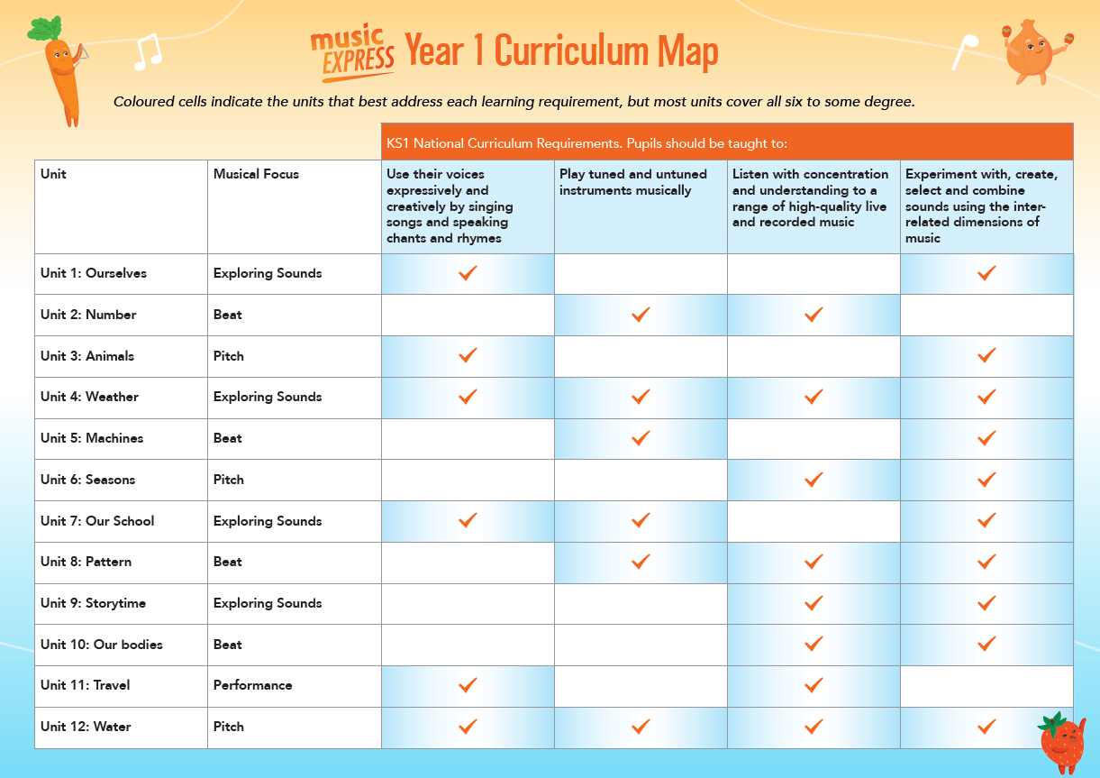
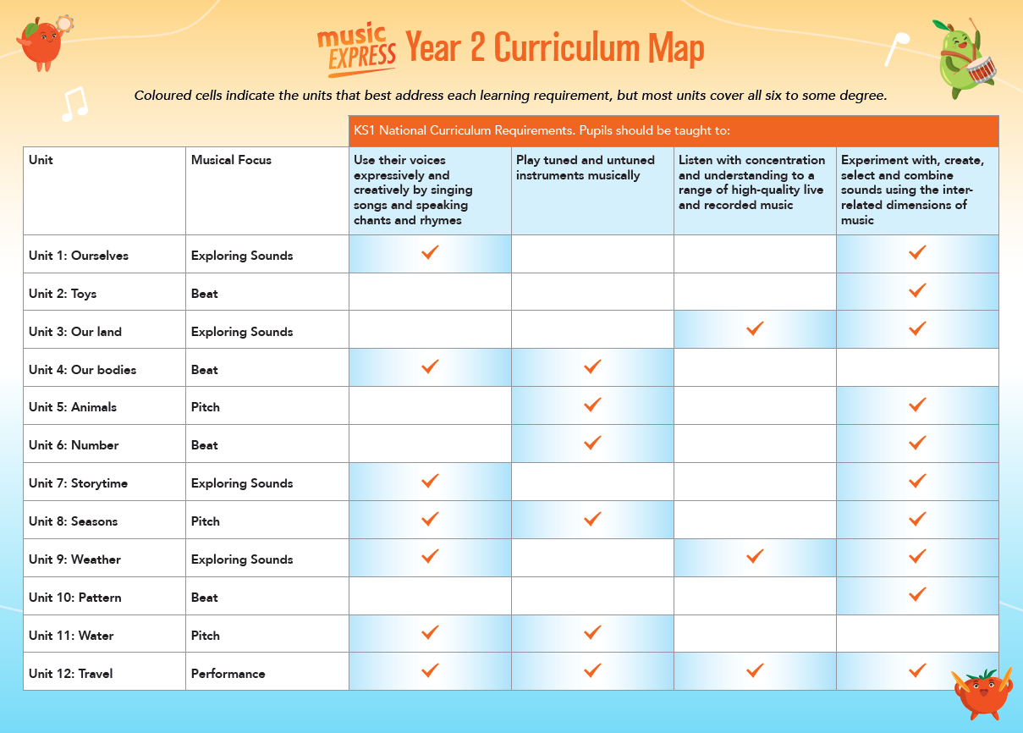

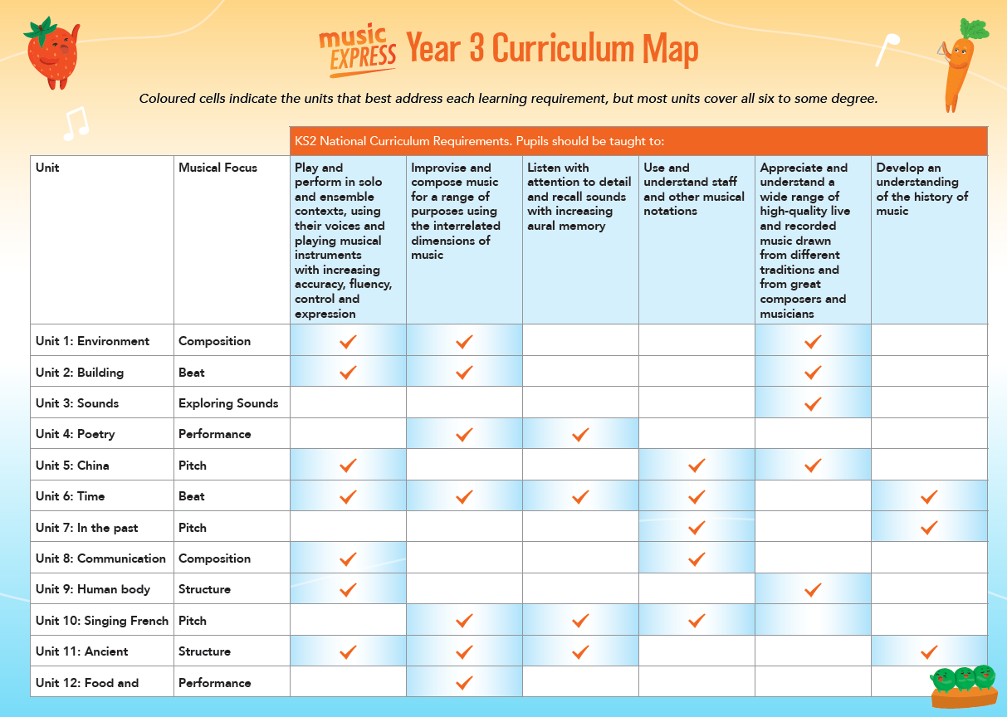

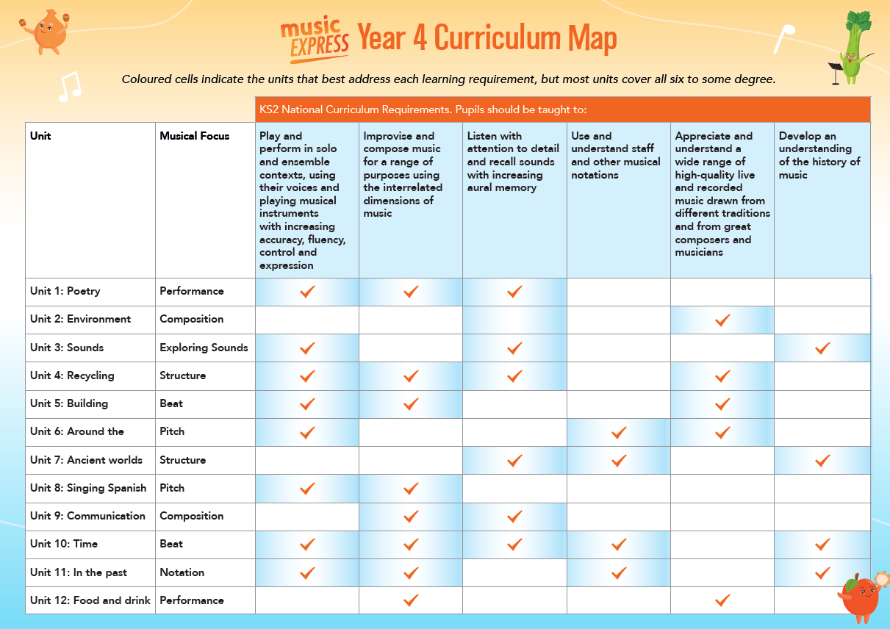
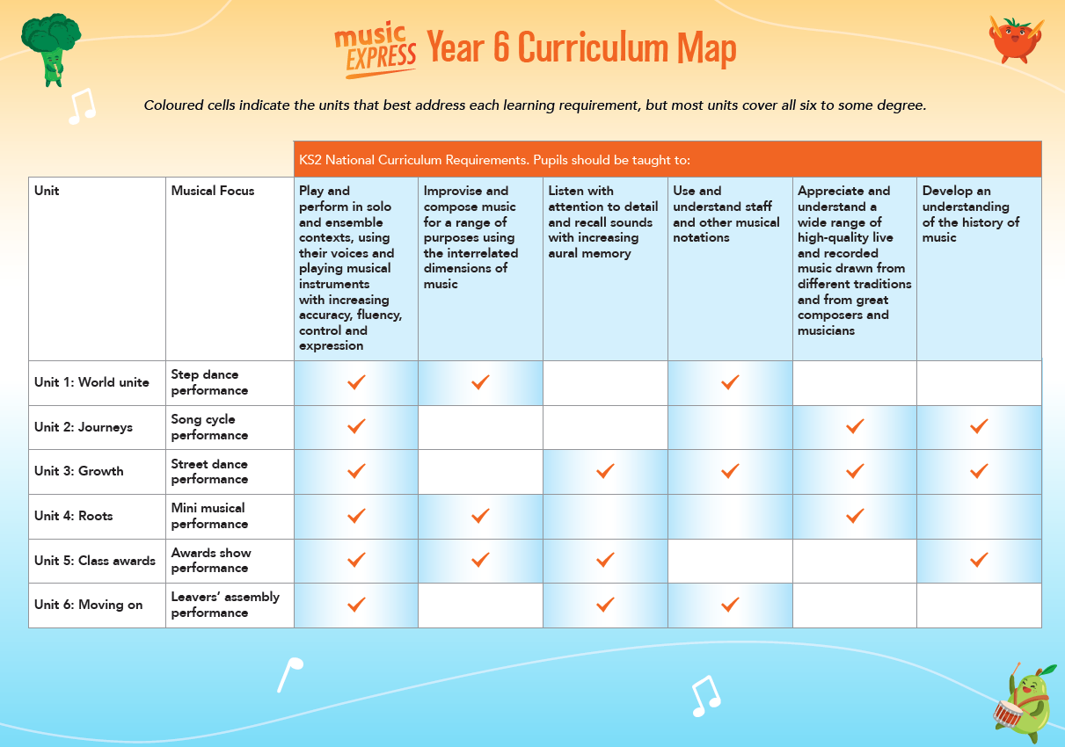
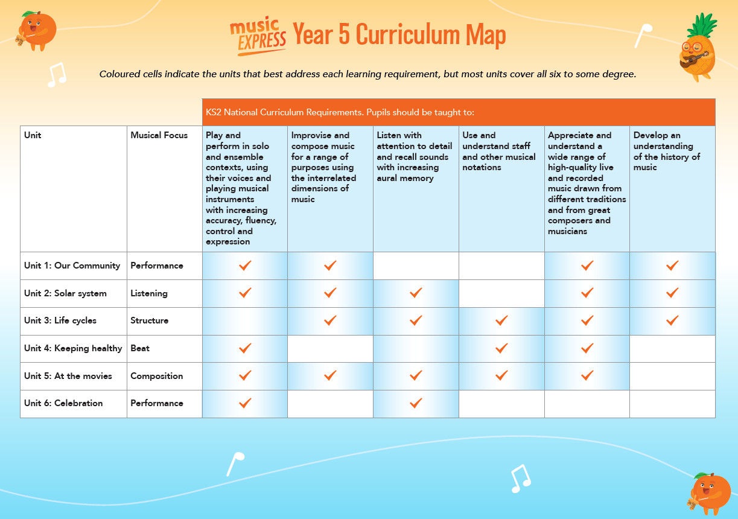
Progressions of skills document:

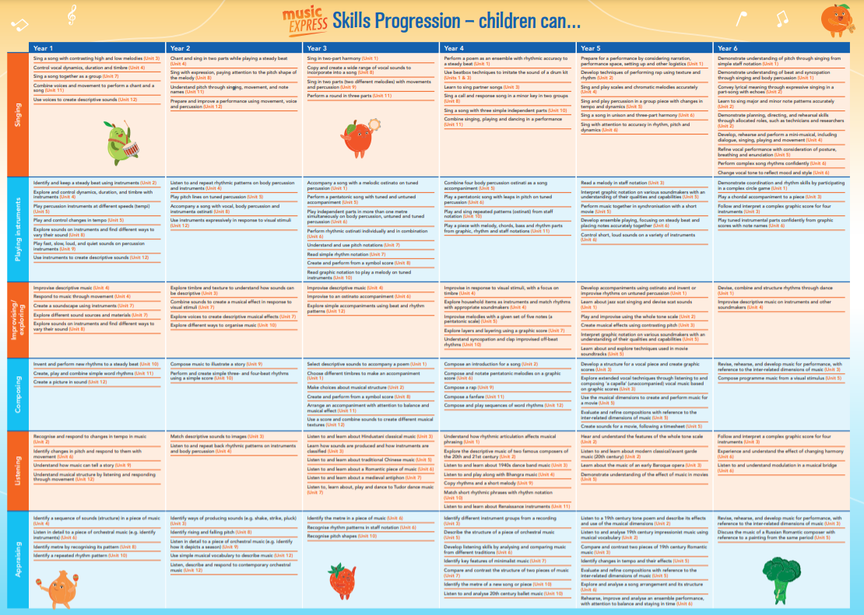

Assessment: The expectation is that all music will be assessed using the Target Tracker statements at the end of each term, however you can add assessments for all statements after each session or at regular intervals throughout the term. This will support in addressing gaps in learning and support the teacher with future planning to ensure progress for all. Alongside this, we use Seesaw to capture the children’s progress and we use a secret ballot system to understand the child’s self-assessment.

Subject Assessments | KS1 | LKS2 | UKS2
Aut 1 | Teacher judgement recorded on Arbor – with Seesaw videos to evidence learning | Teacher judgement recorded on Arbor – with Seesaw videos to evidence learning | Teacher judgement recorded on Arbor – with Seesaw videos to evidence learning
Aut 2 | Teacher judgement recorded on Arbor – with Seesaw videos to evidence learning | Teacher judgement recorded on Arbor – with Seesaw videos to evidence learning | Teacher judgement recorded on Arbor – with Seesaw videos to evidence learning
Spr 1 | Teacher judgement recorded on Arbor – with Seesaw videos to evidence learning | Teacher judgement recorded on Arbor – with Seesaw videos to evidence learning | Teacher judgement recorded on Arbor – with Seesaw videos to evidence learning
Spr 2 | Teacher judgement recorded on Arbor – with Seesaw videos to evidence learning | Teacher judgement recorded on Arbor – with Seesaw videos to evidence learning | Teacher judgement recorded on Arbor – with Seesaw videos to evidence learning
Sum 1 | Teacher judgement recorded on Arbor – with Seesaw videos to evidence learning | Teacher judgement recorded on Arbor – with Seesaw videos to evidence learning | Teacher judgement recorded on Arbor – with Seesaw videos to evidence learning
Sum 2 | Teacher judgement recorded on Arbor – with Seesaw videos to evidence learning | Teacher judgement recorded on Arbor – with Seesaw videos to evidence learning | Teacher judgement recorded on Arbor – with Seesaw videos to evidence learning

Monitoring: The Subject leader will monitor music through use of Target Tracker data, lesson observations, book scrutiny, pupil voice and thorough discussions with teachers. This will be done as per the monitoring schedule and teachers will be advised in advance of these actions.
Music lessons should be taught weekly and although we do not always formally mark music we need to ensure that we have evidence of progression through the use of Seesaw and verbal feedback. Working walls should be in every classroom, outlining current learning and vocabulary relevant to lessons, this vocabulary should mirror the vocabulary used in flashbacks. Music can be evidenced through use of recordings, with QR codes shown on working wall. For monitoring processes, a folder entitled Music should be in your classes Seesaw account.
Knowledge organisers for each half term should be created and saved in the Knowledge Organiser file on the server; these are to be displayed on the music working wall. For further advice and support on the teaching of Music you can access the Kirklees music trust via this link https://www.musicakirklees.org.

Glossary of Music Terms

Accompaniment
The underlying sounds used to support a melody line
Aerophone
An instrument which produces sound using air vibrations, without using strings or membranes
Arrangement
A new version of an existing piece of music
Backing vocal
An additional voice part that complements but is less important than the lead vocal (the main voice part)
Beat/pulse
Beat and pulse are used synonymously to refer to the regular heartbeat of the music – the 'steady beat'
Beatbox
Using your voice, mouth, lips and tongue to produce sounds to imitate the sounds of different instruments, such as the drum kit
Binary
A two-part structure in music is described as binary form: AB. The A and B sections are musically different from each other
Body percussion
Sounds which can be made using parts of the body, eg clapping, tapping knees, etc.
Break
An instrumental or percussion section or interlude in a song
Bridge
A passage of music that links two sections of music together
Call and response
A style of music in which a leader sings or plays a short melody (the call) and a chorus of singers/players respond with an answering short melody (the response)
Canon
When two or more voices or instruments play the same music, starting at different times (also called a 'round')
Chord
Two or more notes played at the same time
Chordophone
An instrument which produces sound using strings that vibrate
Chorus
The part of a song which repeats between the verses
Chromatic
A chromatic instrument is one which is capable of playing every note of the chromatic scale, which is a scale of twelve notes, each a semitone apart, the smallest interval in most Western music. The chromatic scale is: A, A# (Bb), B, C, C# (Db), D, D# (Eb), E, F, F# (Gb), G,G# (Ab)
Cluster
A group of notes that are close in pitch and sounded together
Coda
The end section of a piece of music
Conductor
The person elected to lead a group of singers or instrumentalists
Crescendo
Getting louder
Crotchet
A note that has a duration of one beat
Cumulative
A musical structure in which individual parts join in one by one. It can apply both to the structure of the music itself (as in a cumulative song such as The Twelve Days of Christmas), or to the voices/instruments playing (as in the gradual addition of instruments playing the music of Boléro)
Dimensions/elements
The inter-related building blocks of music (formerly referred to in the English National Curriculum as elements): duration, dynamics, pitch, structure, tempo, texture, and timbre (see definitions)
Diminuendo
Getting quieter

Dot notation
A simple form of Western staff notation. Dots are placed in height and distance relation to each other to indicate pitch and duration
Drone
A sound or sounds played constantly throughout all or part of a piece of music as an accompaniment
Duet
A song or piece of music for two parts of equal importance
Duration
The word used in music to refer to the length of a sound or silence
Dynamics/volume
The loudness of the music, usually described in terms of loud/quiet
Echo
When a musical phrase is repeated after itself, like an echo
Expression
The emotion in music
Fanfare
A short piece of music usually played on brass instruments to announce a special event or occasion
Flash mob
A group of people who collect together in a public space and suddenly perform music or dance
Free/arrhythmic
Music which has no discernible steady beat
Glissando
A slide up or down from one musical note to another, in the manner of a rapid, sliding scale
Graphic notation
A form of notation in which the composer freely invents symbols which give an impression of sound
Graphic score
A score in which musical intention is recorded by means of graphic symbols
Groove
A short section of rhythmic layers, repeated over and over again
Harmony
The relation of two or more notes that are played at the same time
Hocket
One single melody shared between one or more voices or instruments
Idiophone
An instrument which produces sound using the instrument’s vibration, without using strings or membranes
Improvisation
A piece of music which is created spontaneously
Improvise
To invent music as you go along
Interlude
An instrumental or percussion section or 'break' in a song
Introduction
The beginning section of a piece of music
Key
The ‘key’ of a piece of music refers to the scale on which the music is based and around which related harmonies are built. For instance a piece may be in the key of C major, meaning that its tonic, or home note, is the note C and the notes of its scale are C D E F G A B C
Layers
Individual lines of music performed together to create the texture
Lead vocal
The main voice part in a song – usually sings the melody
Leap
The space between two musical notes which is greater than a step (see Step movement)
Lyrics
The words of a song
Major
One of the most common types of eight-note musical scale. Often described as having a happy sound (see also Minor)
Melodic phrase/phrase
A small unit of a melody, often corresponding to a line of a song
Melody
A tune
Membranophone
An instrument which produces sound using a stretched membrane that vibrates
Metre
The grouping of beats into twos, threes, fours, etc, for instance in waltz music the beats are grouped in threes, whereas in march music they are grouped in twos or fours
Mickey mousing
A movie technique where music correlates with the action depicted on screen
Middle eight
A type of musical bridge – it is a short eight-bar passage in the middle of a song that links two sections
Minimalism
A style of composition based on the idea of simplicity that uses repetition and short and simple melodies
Minor
One of the most common types of eight-note musical scale. Often described as having a sad sound (see also Major)
Modulation
The changing of music into a different key
Notations
Ways of writing music down – examples include graphic notation and staff notation
Ostinato (plural ostinatos/ostinati)
A short rhythmic or melodic pattern which is repeated over and over
Pentatonic
A five-note scale, of which there are many types. One of the most common can be played using only the black notes on a pian
Pictorial symbols
A simple form of notation in which a picture is used to represent a sound, eg car picture = motor sounds
Pitch movement
The steps and leaps by which a melody moves up and down in pitch
Pitch
Refers to the complete range of sounds in a piece of music from the lowest to the highest
Pizzicato
The technique of playing a string instrument, eg violin, by plucking the strings rather than playing them with the bow
Playing methods
Acoustic (non-electronic) sounds are made by shaking, scraping, tapping, or blowing a sound maker
Quaver
A note that has a duration of half a beat
Rest
A silence
Rhythm pattern
A short section of rhythm
Rhythm
Patterns of long and short sounds played within a steady beat
Rhythmical
Music which is underpinned by a steady beat
Riff
A short rhythmic or melodic pattern that is repeated over and over (also called an 'ostinato')
Rondo
A structure that has a recurring theme (A) alternating with contrasting sections: A B A C A D A
Round
When two or more voices or instruments play the same music, starting at different times (also called 'canon')
Scale
A group of notes notated or played in order of pitch
Scat singing
A style of vocal improvisation which uses nonsense sounds (instead of words) to imitate the sound of an instrument
Score
A written representation of music designed to record a composer's intention
Sequence
Musical phrases or parts played individually one after the other
Solo
A piece of music for one singer or instrumentalist
Song cycle
A structure of music in which a group of songs is performed in a defined sequence
Soundmaker
Any sound source used as a musical instrument
Soundscape
A picture in sound
Spiritual
Songs created by enslaved African people in the United States. They are generally expressions of religious (often Christian) faith.
Stave
The set of five parallel lines on which notes are placed to denote pitch and rhythm
Step movement
Notes of a melody which move stepwise up or down

Structure
Most music is underpinned by a structure which may be as simple as beginning, middle and end
Symbol
Any written representation of a sound
Syncopation
Often used synonymously with 'off-beat'. Both refer to a rhythm that emphasises normally weak beats
Tempo (plural tempi)
The speed at which music is performed, usually described in terms of fast/slow
Ternary
A structure of music which has three sections, in which the first is repeated: A B A
Texture
Layers of sound, such as those created by a melody accompanied by a drum beat
Timbre
All instruments, including voices, have a particular sound quality which is referred to as timbre, eg squeaky
Tremolo
The rapid repetition of notes, producing a quavering effect. It can either be on one note or between two notes
Trill
The rapid alternation of two adjacent notes, producing a trembling effect
Tuned percussion
Percussion instruments which make sounds with a defined pitch, eg glockenspiel
Unison
When two or more voices/instruments sing or play the same melody at the same time
Untuned percussion
Percussion instruments which make sounds of indefinite pitch, eg hand drum
Verse
The section of a song which generally ‘tells the story’
Waltz
A piece of dance music in 3/4-time where the first beat is emphasised

