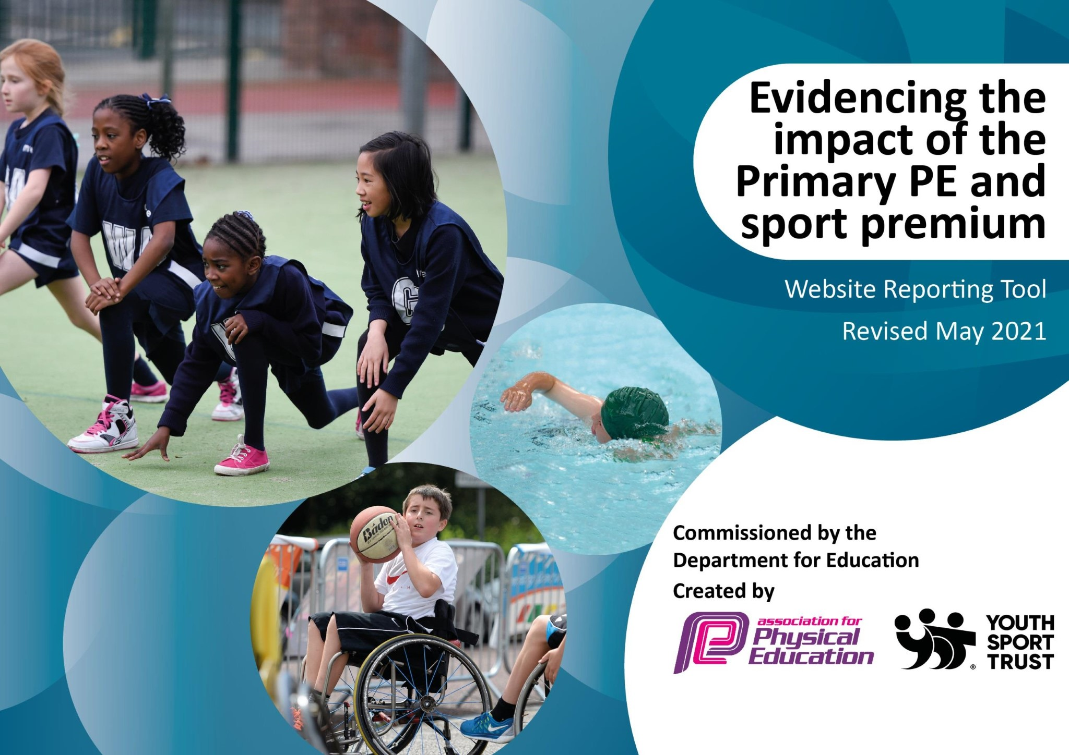

Support for review and reflection - considering the 5 key indicators from DfE, what development needs are a priority for your setting and your
pupils now and why? Use the space below to reflect on previous spend and key achievements and areas for development.

Please note: Although there has been considerable disruption in 2021-22 it is important that you publish details on your website of how you spend the funding - this is a legal requirement. .B. In this section you should refer to any adjustments you might have made due to Covid-19 and how these will influence further improvement.
Key achievements to date until July 2022: | Areas for further improvement and baseline evidence of need:
Despite such challenging times, Sport has continued at Carlinghow and children have kept active having a huge benefit on wellbeing.  -P.E coordinator has re-established links with the Kirklees partnership and School games platform and reintegrated links with SPIRAL P.E to make benefits of the package offered to school.  -SEN Boccia session has reignited passion for Sport in SEN children and this will continue next year.  -Play leaders have ensured break and lunch times are a more structured, active session.  Swimming routine re-established.  Staff CPD and confidence in teaching P.E through SPIRAL has greatly improved. | Competitive sports and engagement with competitions (Covid prevented this).  Cost of coaching and use of sport premium to maximise high quality coaching (discuss plan for next year with £15000 member of staff) - SEN engagement with P.E to be continued and further developed with a emphasis on learning specific sports skills i.e. cricket/orienteering.  Development of a Sports crew.  Development of daily exercise and monitoring of children’s activity levels.

Did you carry forward an underspend from 2021-22 academic year into the current academic year?
YES/NO * Delete as applicable
Total amount carried forward from 2021/2022
+ Total amount for this academic year 2022/2023 £ 18,590
= Total to be spent by 31st July 2023

Meeting national curriculum requirements for swimming and water safety.

N.B Complete this section to your best ability. For example you might have practised safe self-rescue techniques on dry land which you can transfer to the pool when school swimming restarts.
Due to exceptional circumstances priority should be given to ensuring that pupils can perform safe self-rescue even if they do not fully meet the first two requirements of the NC programme of study.
What percentage of your current Year 6 cohort swim competently, confidently and proficiently over a distance of at least 25 metres?  N.B. Even though your pupils may swim in another year please report on their attainment on leaving primary school at the end of the summer term 2022.  Please see note above. | 88%
What percentage of your current Year 6 cohort use a range of strokes effectively [for example, front crawl, backstroke and breaststroke]?  Please see note above. | 53%
What percentage of your current Year 6 cohort perform safe self-rescue in different water-based situations? | 38%
Schools can choose to use the Primary PE and sport premium to provide additional provision for swimming but this must be for activity over and above the national curriculum requirements. Have you used it in this way? | No
Action Plan and Budget Tracking
Capture your intended annual spend against the 5 key indicators. Clarify the success criteria and evidence of impact that you intend to measure to evaluate for pupils today and for the future.

Academic Year: 2022/23 | Total fund allocated: £18,590 | Date Updated:7/9/21
Key indicator 1: The engagement of all pupils in regular physical activity – Chief Medical Officers guidelines recommend that primary school pupils undertake at least 30 minutes of physical activity a day in school |  |  |  | Percentage of total allocation:
 |  |  |  | 38.9%
Intent | Implementation |  | Impact
Your school focus should be clear what you want the pupils to know and be able to do and about what they need to learn and to consolidate through practice: | Make sure your actions to achieve are linked to your intentions: | Funding allocated: | Evidence of impact: what do pupils now know and what can they now do? What has changed?: | Sustainability and suggested next steps:
Sports Coach Akidemy – Breakfast club, Break time, lunch time provision and after school clubs for all year groups. | - Offer a broader range of after school clubs linked to sport.  - Provide active provision on all break times and lunchtimes.  - Use of zone areas at break and lunch to increase regular activity. | £5000  per year | Children have had access to skills based curriculum and staff have received CPD through a full time sports coach. Teachers are now more confident when teaching P.E. We noe feel we can reduced this support and transfer budget to providing coaching for specific areas such as gymnastic, tennis etc….

Retraining of KS2 play leaders and new Y3 play leaders to enable and  facilitate active breaks &  lunchtimes  • To set up and initiate sporting activities at breaks and lunchtimes  Promotion of safe sporting activities and engagement of all | -  - | Play leaders to be trained and set up activities and promote participation in activities at break and lunch. Play leaders to oversee use of zones and range of activities. | £438  Part of sport staff cost 3 hour weekly admin time.* | This is to continue from last year- the play leaders played a huge part in the successes of the school- playtime is well organised and is purposeful. HG the pastoral leader plays a huge part in support these children. Children have become more confident when leading and supporting others. | .
All teachers to provide a daily opportunity to additional exercise (Run by Sports Staff). to include:  - Daily Mile  - Go Noodle  - Active Lessons | -  - | Continue 1k a day daily session for all classes. Continue daily mile session for focus group of children.  Continue Go Noodle and other opportunities to be active in sessions. | £1170  4 x 15 minute Sports coach daily mile sessions. 1 x hour of additional activity for target children.  2 hours per week at £15 (£30 per week x  39 weeks) | To continue from last year-
Whole-school survey to be conducted to identify and target children who do not take part in any physical activity outside of school.  - Communication with specific children to target involvement  - Redirection of Activities coordinator hours to provide sports based after school clubs Promotion of additional activities for children outside of school in a broader range of activities including disability sports. | -  -  - | A survey will be carried out identifying children to take part in daily mile and other focused activities.  Sports clubs will be planned and delivered in line with finding of survey.  Reengagement with NKSPP to increase chances to participate for all year groups. | £439  Part of sport staff cost 3 hour weekly admin time. * | Our children are encouraged to be part of our school improvement and as such we value pupil voice and will continue to survey the children.

Purchase of spare PE kit to ensure all pupils have PE kit (including pumps) if not provided from home | - Spare P.E kit to be ordered. |  | £200 | We endeavour to make sure that all children are in correct P.E 100% of the time. There are occasions when children forget P.E kit the impact of this funding is that we can make sure they are dressed suitably for P.E. |  | .
Key indicator 2: The profile of PESSPA being raised across the school as a tool for whole school improvement |  |  |  |  |  | Percentage of total allocation:
 |  |  |  |  |  | 4.6%
Intent | Implementation |  |  | Impact
Your school focus should be clear what you want the pupils to know and be able to do and about what they need to learn and to consolidate through practice: | Make sure your actions to achieve are linked to your intentions: |  | Funding allocated: | Evidence of impact: what do pupils now know and what can they now do? What has changed?: |  | Sustainability and suggested next steps:
PE coordinator to ensure PE grant delivery enhances the provision for all of our children  • Monitoring the effective delivery of the PE Curriculum and accuracy of PE assessment.  Monitoring of Grant Funding Plan and Management of our sports member of staff. | - P.E lead to monitor delivery of P.E lessons in subject coordinator week.  - P.E coordinator to liase with assessment lead to ensure  P.E assessment is now happening.  - Deputy Head of School (line manager of sports staff) to monitor work of sports staff and regularly check quality of work and impact on children/P.E. |  | £439  Part of sport staff cost 3 hour weekly admin time. * | - All teachers teaching a progressive skills based PE  curriculum  - Monitoring shows of the PE curriculum is being taught effectively and assessed accurately.  Compliance with the grant funding agreement – evaluations reported to senior leaders for approval.
Provision, organisation, communication and celebration of ‘Sports Week’ – A opportunity to further engage parents and children in a variety of sporting activities alongside mental health and healthy living awareness.  Increase House event system and inter class competitions. | -  -  -  - | Sports week to be organised and held.  House sports events will be organised.  P.E coordinator to feedback information from P.E cluster meetings on mental health and healthy living initiatives. House system will be a weekly part of assembly and celebration events. | £420 | • | Raising the profile of sport and healthy lifestyles and mental health across the whole school. To increase parental awareness of healthy lifestyles and mental health and parental engagement  with the school. Sports Week feedback  illustrates impact.
 |  |  |  | • | Children will have the chance to take part in more House events in school increasing a sense of community and building confidence.

Key indicator 3: Increased confidence, knowledge and skills of all staff in teaching PE and sport |  |  |  | Percentage of total allocation:
 |  |  |  | 8%
Intent | Implementation |  | Impact
Your school focus should be clear | Make sure your actions to | Funding | Evidence of impact: what do | Sustainability and suggested
what you want the pupils to know | achieve are linked to your | allocated: | pupils now know and what | next steps:
and be able to do and about | intentions: |  | can they now do? What has
what they need to learn and to consolidate through practice: |  |  | changed?

Training and planning support from PE Coordinator and CPD for teachers. To target skills gaps as identified from staff feedback using staff meeting time effectively to deliver wider messages and updates. | - Invite Spiral Staff in to deliver CPD sessions.  - Subscribe to SPIRAL P.E Programme. | Spiral Package  £1000
Purchase of PE equipment to support the teaching of the PE curriculum. | Sports Staff to half termly audit P.E  equipment and play/lunch equipment and meet with  Deputy head of school to discuss new resources needed. | £500 |  | .

Key indicator 4: Broader experience of a range of sports and activities offered to all pupils |  |  |  | Percentage of total allocation:
 |  |  |  | 36%
Intent | Implementation |  | Impact
Your school focus should be clear | Make sure your actions to | Funding | Evidence of impact: what do | Sustainability and suggested
what you want the pupils to know | achieve are linked to your | allocated: | pupils now know and what | next steps:
and be able to do and about | intentions: |  | can they now do? What has
what they need to learn and to consolidate through practice: |  |  | changed?:
Offer of a broad range of sports and activities through weekly afterschool clubs. |  | £3450 (cover staffing costs for additional clubs/  competitions)  Capacity to pay for an additional  5 x  Breakfast/after school sports club hours at £15 per hour) | All children will have the chance to participate in sports and  activities that are not part of the routine P.E curriculum.
Purchase of specialist coaching and resources to facilitate a broader range of sports and activities in after school clubs. | -Purchase quality dance coaching for Autumn 1 to offer curriculum sessions and breakfast club to promote and raise profile of dance in school. | Orienteering £1700  Skateboard sessions  £840  Martial arts  £60 x 2 x 6= £720 | This will allow children to participate in sports and activities that are not part of the routine P.E curriculum and provide higher quality experiences than what we currently offer.

Key indicator 5: Increased participation in competitive sport |  |  |  | Percentage of total allocation:
 |  |  |  | 20%
Intent | Implementation |  | Impact
Your school focus should be clear what you want the pupils to know and be able to do and about what they need to learn and to consolidate through practice: | Make sure your actions to achieve are linked to your intentions: | Funding allocated: | Evidence of impact: what do pupils now know and what can they now do? What has changed? | Sustainability and suggested next steps:
PE Coordinator to create calendar of inter-house and external sporting competitions | -On receipt of NKSPP calendar, P.E staff member to identify which competitions children at  Carlinghow could attend ensuring opportunities for all.  - Sport staff member to factor this into planning and delivery of sessions.  P.E coordinator to manage paperwork and practicality side of entering competitions.  -Inter house events to be set up across the year. | £439  Part of sport staff cost 3 hour weekly admin time. * | Provides;  - opportunities for children to take part in healthy competition within school.  - participation in external sporting events.  - opportunities for children to apply skills learnt in lessons and clubs.  - opportunities for children to take part in healthy competition within school.
Subscription to NKSSP partnership This will allow for competition access and further CPD opportunities | - We will engage with the NKSPP calendar of events and ensure children are given the chance to participate in a range of competitions and events. | £ 1356 | Children are able to participate in competitive sports and are exposed to new competitive opportunities.
Financial contribution to cover the cost of transporting children to competitive sporting activities. | -Use money to cover transport costs for attending competitions.  Look to hire minibuses for school use to enable us to engage in more activities and not be restricted by coach cost and times.  Blue badge training for staff to drive mini bus | £1918 | -Transport costs are not a barrier to entering competitions and Carlinghow can attend a range of different events. | .
*3 hour per week at £15 (£45 per week x 39 weeks) = admin time

Details with regard to funding
Please complete the table below.

Total amount carried over from 2020/21
Total amount allocated for 2021/22
How much (if any) do you intend to carry over from this total fund into 2021/22? | N/A
Total amount allocated for 2022/23 | £18,590
Total amount of funding for 2022/23. To be spent and reported on by 31st July 2023 | £18,590

Key achievements to date until July 2022: | Areas for further improvement and baseline evidence of need:
-

Swimming Data
Please report on your Swimming Data below.
Meeting national curriculum requirements for swimming and water safety.

N.B. Complete this section to your best ability. For example you might have practised safe self-rescue techniques on dry land which you can then transfer to the pool when school swimming restarts.
Due to exceptional circumstances priority should be given to ensuring that pupils can perform safe self-rescue even if they do not fully meet the first two requirements of the NC programme of study
What percentage of your current Year 6 cohort swim competently, confidently and proficiently over a distance of at least 25 metres?  N.B. Even though your pupils may swim in another year please report on their attainment on leaving primary school at the end of the summer term 2020.  Please see note above | 88%
What percentage of your current Year 6 cohort use a range of strokes effectively [for example, front crawl, backstroke and breaststroke]?  Please see note above | 53%
What percentage of your current Year 6 cohort perform safe self-rescue in different water-based situations? | 38%
Schools can choose to use the Primary PE and sport premium to provide additional provision for swimming but this must be for activity over and above the national curriculum requirements. Have you used it in this way? | Yes/No

Action Plan and Budget Tracking
Capture your intended annual spend against the 5 key indicators. Clarify the success criteria and evidence of impact that you intend to measure to evaluate for pupils today and for the future.

Signed off by
Executive Principal: | D. Worthington
Head of School: | Marie Fishwick
Date: | 17/9/21
Subject Leader: | Callum Ivel
Date: | 17/9/21
Governor: | D. McConnell
Date: | 17/9/21

