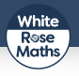
White Rose Maths is excited to have produced a range of work booklets for parents and children to use over the summer or during next year. These booklets can be found on Amazon for the Kindle or downloaded below. There is one booklet for each of our blocks for Y1 to Y6.

Choose from Year 1, Year 2, Year 3, Year 4, Year 5, Year 6,
Home Learning

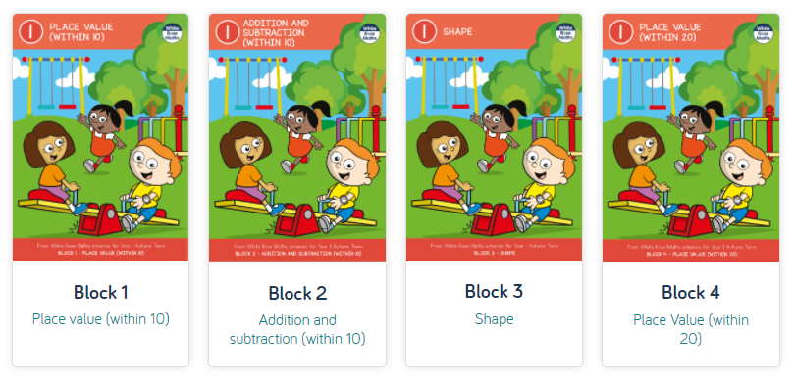

This fantastic resource can be accessed https://whiterosemaths.com/parent-workbooks/

