


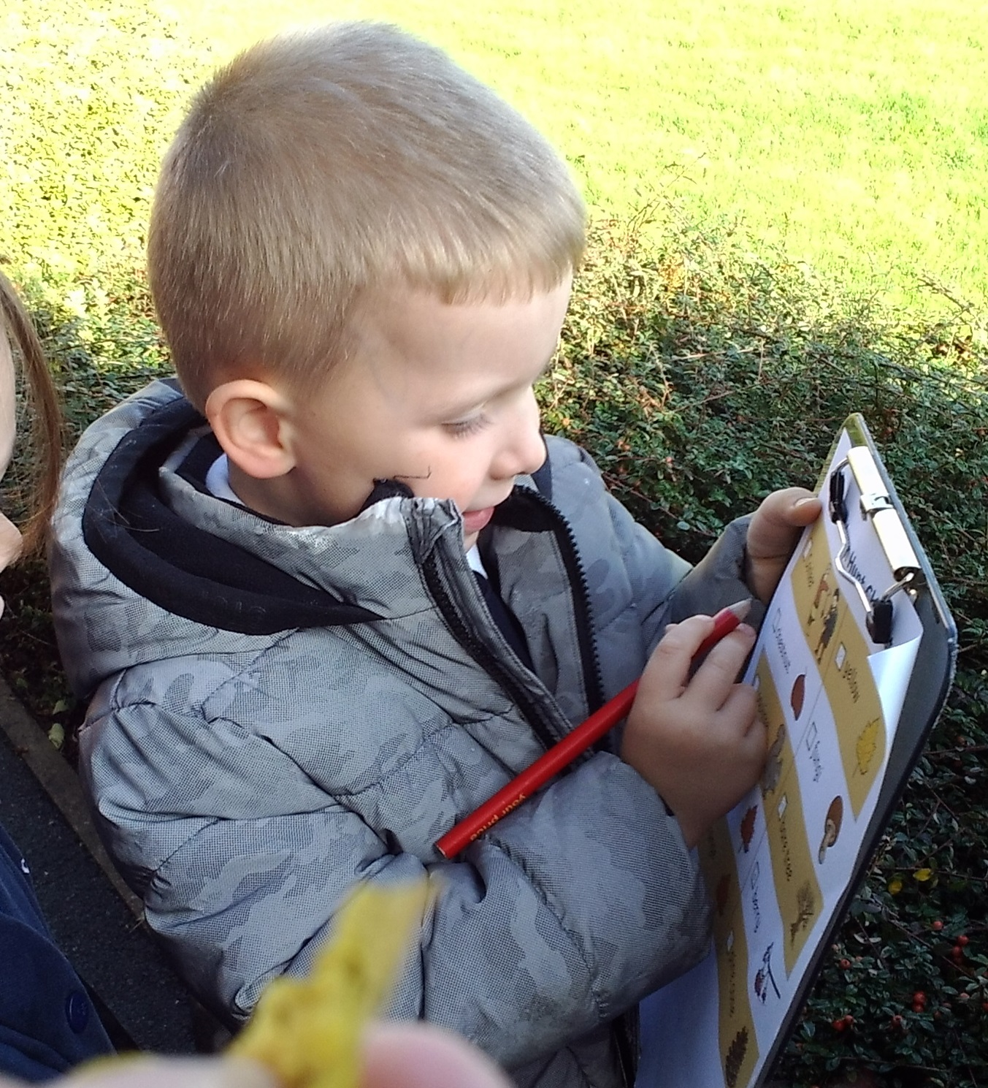

Reception Booklet 2020
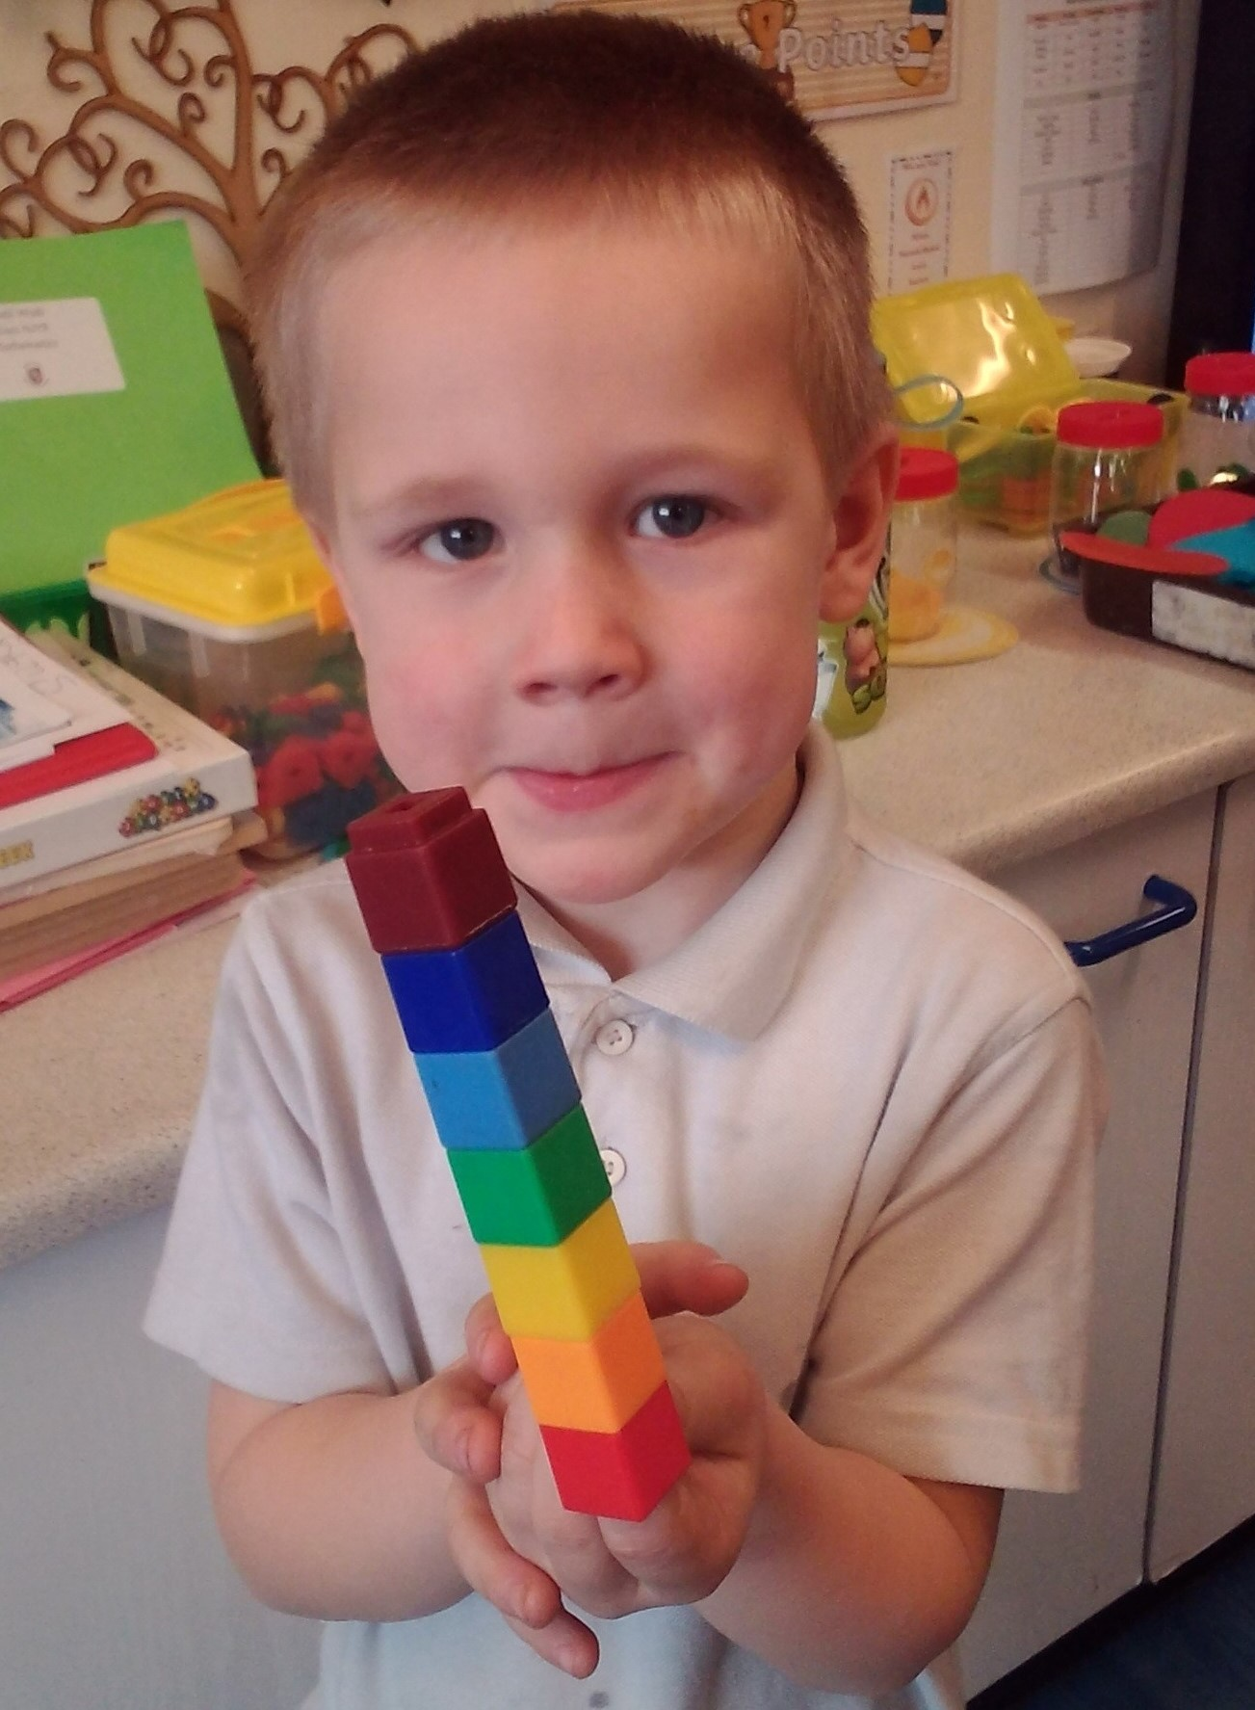

Welcome

Achieving excellence together
Contents
Message from Our Principal p. 2
School times/Absences p. 3
Smooth Transition p. 4
A Typical School Day p. 5
Baseline Assessment p. 6
Curriculum p. 7
Play-Based Learning p. 8
WOW Moments/Weather p. 9
Reading p.10
Parent participation p.11
School Dinners p.12
School Uniform p.13
Preparation/Contact Us p.14

Principal's Welcome
I would like to welcome you to Carlinghow Academy.
I hope that you find this booklet interesting and full of all the information you need to know about your child starting school.
I firmly believe that in order to provide the best outcomes for children, education must be seen as a team effort between the teachers, the school as a whole, the parent and the child, and therefore I extend a warm welcome to you and your families and look forward to securing a happy and successful working partnership.
If there is anything that you are not sure about, or you have any questions that this booklet or our website does not answer, please don't hesitate to contact us and we will try to answer your query.
Miss D Worthington, Principal



School Times
The bell is rung at 8.50 am each morning and the children line up in the playground outside their classroom.
They are collected by their teachers and brought into school.
Any messages can be passed on to teachers here, including changes to collection arrangements.
To maximise the safety of all children, the gates to the back of the school are locked at 9.05 am each morning. Any late arrivals need to come into school through the main entrance door. At home time the gates situated at the side of the school are are opened at 2.50 pm and children will be let out of class at 3.00 pm. The children are released only to a known adult from the Reception conservatory doors.
The barrier leading to the carpark remains down. If you have a disability badge, and therefore use the staff car park, access will be given through the main entrance.

Absences

Please notify school if your child is ill, either by telephone or by another adult in person in the morning: by 9.30 am on 01924 326371.
We will contact you if we have not heard from you by this time.
Sickness - 48 hour rule - if your child is suffering from sickness or diarrhoea they need to be clear of symptoms for 48 hours before returning to school.

Holidays
Term time dates are published in the Academy Newsletter early in the academic year and are also on the website. The Principal may not grant any leave of absence during term time unless there are exceptional circumstances. For full details of our attendance policy please visit the Academy website.

Smooth Transition
Starting in Reception is an exciting time but we also appreciate that it can bring with it feelings of worry and anxiety for both children and parents/carers. In light of this, we strongly believe that successful transition begins by building strong relationships between the staff, the child and their families.

We aim to achieve this by:

- Running a staggered start during the first week of the new school year in September. Reception staff will confirm with you what days your child will attend. This will allow staff more time to get to know your child and it will also be an opportunity to help settle children who may feel less confident or who may feel overwhelmed in a larger group.

- Inviting children in for a transition visit where they can spend the morning getting to know their new teachers and peers.

- Carrying out a home visit for children who are new to Carlinghow Academy. Two members of staff will visit your child at home. During this visit staff will spend time talking to yourself and your child and they will observe how your child plays/interacts in a familiar environment. The staff will find out about your child’s interests and likes so that they can prepare the classroom environment to accommodate these. This ensures your child feels as settled as possible.

- Spending the first 4 weeks carrying out baseline assessments in school.

- Allocating your child a key worker so they can form a close relationship with a familiar adult.

- Sharing assessment information through reports, parents’ evenings and an online learning journey.
A Typical School Day

8:50 The school bell rings, the children line up outside their door and are met by the teachers. Children are encouraged to come into the class on their own and put away their coats and book bags independently. The children then complete a morning task.
9:00 Register
9:10 Assembly
9:30 Phonics input. This is a whole class carpet session.
9:45 The children are able to explore & play both inside and out with a range of resources and activities. A focused adult-led Phonics or Maths activity will be set up which all children will complete at some point in the morning session.
11:15 Tidy up time.
11.25 Maths input. This is a whole class carpet session.
. 11.45 Toileting and washing hands for lunch. Children have lunch and play outside when they have finished. While Reception staff are on lunch, the children are facilitated by Mid Day Supervisors.
12:45 Afternoon Registration. Children stay on the carpet for an input session which is usually a focus developing Understanding of the World 0r Expressive Art & Design, however these sessions can be flexible depending on the learning.
13:30 The children are able to explore & play both inside and out. A focused adult-led investigation or creative activity will be set up which all children will complete at some point in the afternoon session.
14:30 Tidy up time, prepare for home time
14.40 Story time
15:00 Parents collect children at the door of the classroom.

Baseline Assessment

When your child starts in Reception class, their teachers will spend the first 4 weeks getting to know them through a baseline assessment. The baseline assessment builds a ‘picture’ of your child looking at: well-being, characteristics of effective learning, prime areas and specific areas.

Teachers will capture the baseline assessment through:
- Observations of children’s play and interactions
- Planned activities in provision
- Speaking to parents and carers
- Home visits
- Discussions with previous settings

Children will only be assessed when they are displaying high levels of involvement and well-being as we recognise that the most important job at the start of the year is to ensure that your child makes a happy and settled transition to school.

During this time we will support children to establish positive relationships, understand classroom routines and become familiar with the adults in their class.

Once baseline assessments have been completed, teachers will use this information to plan for exciting learning opportunities and provision that are matched to the interests and abilities of all children. For this reason, it is important that you share as much information with your child’s teacher as possible: especially about your child’s interests and the things that excite them.

Curriculum

Early Years Outcomes
Throughout the year children’s progress is reviewed against the Early Years Outcomes and at the end of reception children are assessed against each of the 17 Early Learning Goals.
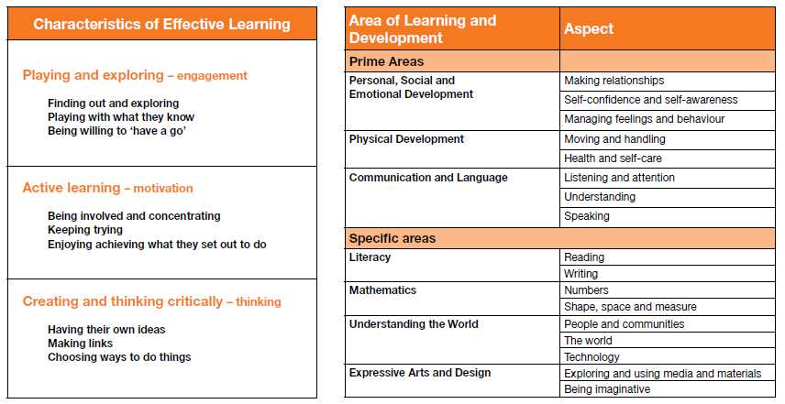

The Characteristics of Effective Learning describe key dispositions which play a central role in your child becoming an effective learner. They form the basis of transition discussions as children move from nursery to reception and then from reception to Y1.

Further information about the Early Learning Goals (ELGs) can be found on the following website:

https://www.gov.uk/government/publications/eyfs-profile-exemplication-materials

Play-Based Learning

In Reception children learn largely through child initiated activities and play-based experiences. Staff carefully plan indoor and outdoor provision to capture your child’s imagination, promote independent learning and encourage interactions with peers across a range of contexts.

There are carpet sessions timetabled throughout the day where the children come together to learn about phonics, literacy and maths as well as understanding the world and expressive arts and design. Focussed activities are then planned to provide the ‘next steps’ to support your child’s progress and development.

Similar to the baseline, staff will dedicate time to observing your child as they play, interact, problem-solve and choose their own activities.

Areas of continuous provision include:

- Construction
- Water
- Play Dough
- Creative
- Sand
- Outdoors
- Role-Play
- Small-World
- ICT
- Library

.

Wow Moments

At Carlinghow Academy we like to work in partnership with parents and we encourage you to take an active role in your child’s education.

We love hearing about the exciting experiences your child has outside of school, including special visits and outings as well as day to day activities such as sharing a book at bedtime, learning to ride a bike, playing a game, visiting family etc…

Your child’s class teacher will have ‘wow slips’ available for you to share your child’s WOW moments.

Whatever the Weather!

Part of our curriculum in reception is ‘Understanding the World’, so please be aware that we like to play out in all weathers!

Children absolutely love exploring their natural environment and what better way to do this than to experience the changing seasons first hand?

During the wet months we ask that you provide your child with a hooded, waterproof coat, a pair of wellies and a spare pair of socks.

We also like to get hands-on so please be aware that, on occasion, your child’s clothing might not be as clean as when they first came to school in the morning!

Wherever possible we will provide children with aprons but we ask you to understand that children generally have a way of getting messy no matter what and if it’s only a little bit of dirt or paint it should come out in the wash!
Reading
Reading at home is THE best way you can support your child’s learning!
We encourage you to share books EVERY night whether they are home reading books or picture books.
Sharing books has significant benefits including:
- Enjoyment
- Strengthening bonds between parent and child
- Improving speaking and listening skills
- Promoting a love of reading
- Giving your child the best start to their education

School Library and Story Sharing
Once you have signed a library agreement, your child may borrow books from our school library. Throughout the year we will offer story sharing sessions where parents/carers are invited into class to share stories with children.

Home Reading
In Reception, children begin to formally learn letter sounds and names through a systematic approach to teaching phonics. Once children are confident to segment and blend sounds for reading simple words they will start to bring home reading books with text. Please support your child to read these books at home or encourage other family members, like older siblings or aunts/uncles, to get involved. Children will also bring home a reading log which should be filled in every time your child reads.
We encourage children to sound out words (segmenting) and then ‘blend’ the sounds together and children are taught to read some words automatically without the need for sounding out (TWs – tricky words and HFWs – high frequency words).

Don’t forget that sharing books is not just about reading the words, it is just as important to enjoy time discussing the story, characters and illustrations, and children love linking stories to their own experiences.

As well as reading books your child will also bring home letter cards and high frequency words to learn at speed.

Parent Participation
At Carlinghow Academy, we view your child’s education as a partnership between home and school. In order for your child to reach their full potential it is important that we work as a team. At the beginning of the school year, parents are asked to sign a contract; The Carlinghow Academy Home/Academy Agreement. This identifies what we will do together, what we as staff will do, what we expect you as parents to do and finally what we ask of the children. A copy of the agreement terms can be found on the last page of this booklet. We hold regular whole school events which the children really enjoy and we encourage families to be involved; highlights include the Halloween disco and Summer Fayre.
Seesaw
At the Carlinghow Academy we use an app called Seesaw throughout school as an interactive learning platform. It is a simple way for teachers and pupils to record and share what's happening in the classroom. Seesaw gives pupils a place to document their learning, be creative and learn how to use technology. Each child gets their own online journal which follows them up through school. Children are encouraged to take ownership of their learning, they and will add and create photos, videos, drawings, or presentations independently. When there are new Seesaw posts, families can be notified via app notification, email or SMS. Parents are only notified about their own child’s work, and all data is safe and secure
Texts
In order to keep our parents updated with school life and any last minute changes such as closure due to snow we use a text/email service called ‘Groupcall’ which will send a text to mobile phones or an email depending on the urgency of the message.

Parent Pay
We use an electronic payment system ‘Parent Pay’ - where parents can pay for school dinners and trips online. Once your child has started school you will receive information on registration.

School Dinners
Dinners are freshly cooked in our own kitchens. We offer choices each day, including a vegetarian option and the menus rotate over a two week cycle. Fresh fruit and bread are always available, along with water to drink. Menus are changed seasonally and information is sent home for you and your child to choose their lunch. If your child has any specific dietary requirements please let us know so that we can tailor a menu to suit your needs. All pupils in reception, year 1 and year 2 in state-funded schools in England are eligible for Universal School Meals.
Water
Children are encouraged to drink water to keep well hydrated during the school day. To promote a healthy lifestyle this must be water and not juice.

Milk
Milk is available to all children in Foundation Stage and Key Stage 1. For all our under 5's this is free. Carlinghow Academy will automatically register your child to receive school milk each day. When children reach their fifth birthday they can continue to receive milk scheme for approximately £15 per term.

Snacks
At Carlinghow Academy we strive to promote a healthy lifestyle. Children are offered fresh or dried fruit and vegetables, provided by a government scheme to encourage children to eat five a day. This includes a different choice each day e.g banana, carrot, pear, apple or orange. Children are encouraged to peel their own fruit to assist their self-help skills.

School Uniform
Grey skirt / trousers
Blue sweatshirt / cardigan (ideally with the Carlinghow Academy logo)
White cotton shirt
Blue/Grey striped tie
Black shoes - no boots please
In the summer, many girls wear blue/ white check dresses.
All children may wear grey shorts in warm weather
PE uniform
White t-shirt
Navy shorts
Black pumps
PE kit to be kept in a named pump bag.
Children should not come to school wearing fashion trainers, jeans, tracksuits, sportswear or beachwear.
Please ensure all items of uniform are clearly labelled with your child’s name.

Keeping informed
To ensure parents are kept informed of up and coming events, a calendar on our website shows all our diary events. We also publish all letters which are sent home on our website, so it is worth checking our web page at regular intervals to keep yourself informed.

Breakfast club
To ensure your child has a great start to the day our dedicated staff operate a Breakfast Club for our pupils. Children can choose from a variety of breakfast options as well as daily activities. This club starts at 8am each school morning. Places are limited and must be booked prior to attending.

Preparation
Many parents ask what we want children to do before they come to school.

Here are the things which help to make the school day and routines simpler:

- I can use the toilet all by myself
- I can zip up and fasten my coat
- I can dress myself and change for PE
- I can wash and dry my hands & face
- I can use a knife & fork
- I can put on my own shoes and fasten them

Getting in touch

Carlinghow Academy
Ealand Road
Batley
WF17 8HT
01924 326371
office@carlinghowacademy.org.uk

Building a partnership between Home and the Academy
TOGETHER WE WILL:
- Help our children to feel happy, confident and valued at Carlinghow Academy.
- Promote in them a clear understanding of good manners and right and wrong.
- Share common expectations to enable everyone to reach their maximum potential.
- Create a safe and secure environment where our children can flourish.
- Establish open and respectful communication between all members of The Academy community.
- Develop a shared understanding of the behaviour policy expectations.
- Celebrate, share and praise successes.
THE ACADEMY STAFF WILL:
- Work within all policies, values, aims and visions set by the Governors.
- Provide an open and welcoming environment where you and your child will feel valued.
- Recognise and build on your child’s unique strengths.
- Set accurate and helpful targets for you and your child to work on.
- Keep you informed of your child’s progress and offer encouragement and support.
- Be available to discuss your child’s progress formally annually and informally by mutual arrangement.
- Endeavour to arrange Academy events and meetings to meet the needs of families.
- Ensure respectful communication by providing appropriate lines of communication which are accessible, regular and considered.
- Have available on request information about the complaints procedure.
IN RETURN WE ASK THAT PARENTS:
- Support and respect the Academy’s policies, values, aim and visions.
- Support the staff in their care and education of your child.
- Ensure that your child is punctual and attends The Academy regularly.
- Avoid taking holidays during term time.
- Attend and support Academy events, meetings and celebrations wherever possible.
- Create a sense of belonging by ensuring children wear the requested Academy uniform.
- Ensure respectful communication by liaising with the appropriate Academy Staff.
- Notify the Academy of any changes of circumstances that might affect the child.
- Let us work together to make our partnership one of confidence, enthusiasm and respect.
IN RETURN WE ASK THAT CHILDREN:
- Take care of everyone and everything so that:

The Academy is a happy place, we can all learn, nobody gets hurt, we are all safe, nothing
gets spoilt or lost. And we take care of ourselves so that we can stay fit and healthy.

