|  |  |  |  |  |  |
| --- | --- | --- | --- | --- | --- |
|  |  | | | |  |
| **SUMMARY INFORMATION** | | | | | |
| **Academic Year** | | 2020/21 | **Total number of pupils** | 290 | |
| **Cost per pupil** | | £80 | **Total catch-up budget** | £23,200 | |
| **Catch-up funding leader** | | Dani Worthington | **LGB member responsible** | John Flynn | |
| **Catch-up funding Trust leaders** | | Amanda Bennett CEO  Amanda Rawson CFO  Ken Inwood - Trustee | **Review Processes** | Monthly on-going log. Half termly financial spend review – Termly impact reporting. | |



|  |
| --- |
| **Context / foreword** |
| For educators, coronavirus has created the test of a generation. When pupils start the new school year in September, most will be returning to the classroom for the first time in almost six months. In order to allow our children to ‘catch-up’ the learning they have missed, the government has provided funding at £80 per pupil for each school/academy. Following research and the EEF document “COVID-19 SUPPORT GUIDE FOR SCHOOLS”, this strategy sets out the academies plans to provide the necessary resources and approaches to allow our children to settle back into school and accelerate their learning in order to ‘narrow the gaps’.  <https://educationendowmentfoundation.org.uk/covid-19-resources/guide-to-supporting-schools-planning/> |

|  |
| --- |
| **Priorities identified through school’s analysis** |
| * *Year 1 curriculum offer re transition focus to Key Stage 1 (S&L/Phonics/ BFL)* * *Reading-Phonics, early reading and vocabulary in Year 2,Phonics and early reading in Year 3 ,Reading in upper KS2* * *SEL across school with particular focus in Year 2,3 and 5* * *Year 6 curriculum offer (maths and English/bfl/SEND) in order to be secondary ready* |

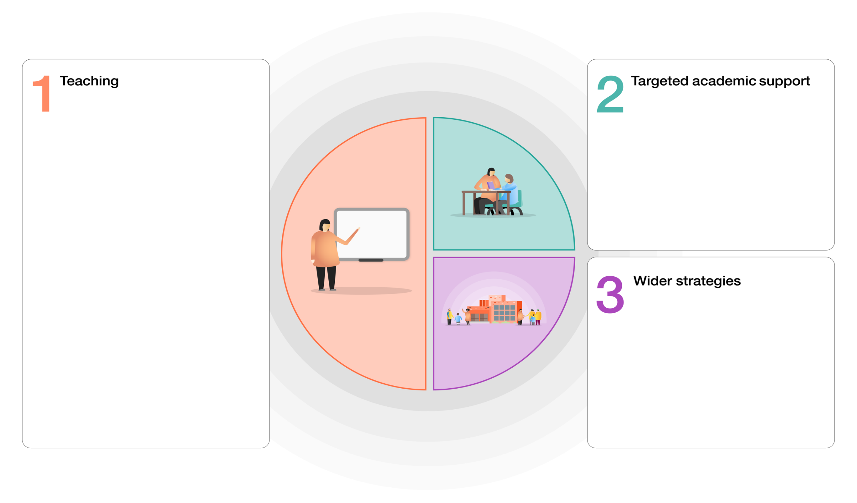**EEF GUIDE TO SUPPORTING SCHOOL PLANNING (2020-21) – TIERED MODEL – Catch-up focussed model**

**3 – WIDER STRATEGIES**

* Extensive outdoor learning provision
* Breakfast Club provision continued.
* Symbiosis between whole school offer (SDP) and Pupil Premium Strategy.
* Use of Seesaw to maintain high level of parental engagement and provide additional support materials.
* Introduction of new positive behaviour policy across the school and a focus on whole class rewards.
* PSHCE curriculum (Jigsaw) supporting emotional wellbeing
* Whole School re engagement project to support emotional well-being.

**2 – TARGETED ACADEMIC SUPPORT**

* Same-day in-class intervention.
* Specific intervention programmes led by both Teachers and Teaching Assistants using research led diagnostics and intervention programmes.
* Provide Research School led literacy CPD to ensure high-quality teaching.



**1 - TEACHING**

* Quality First Teaching supported by evidence informed CPD for teachers and support staff.
* A broad and engaging curriculum that focuses on vocabulary acquisition and application of basic skills.
* Frequent low stakes testing to ensure all students, and in particular disadvantaged students, experience success and celebrate the acquisition of knowledge.
* Maintain our existing CPD focus on Literacy and introduce further CDP on metacognition through a logical and well-sequenced plan to support and sustain high quality teaching.
* Continued focus on workload to aid staff wellbeing and enable high-quality responsive teaching based on formative assessment and diagnostics.
* Introduction of EEF Metacognition Guidance with a trained trainer on the leadership team to ensure implementation.
* Continued whole school focus on oracy including introducing continuous provision in Year 1 to support this.

**IMPLEMENTATION PLAN FOR CATCH-UP**

|  |  |  |  |  |
| --- | --- | --- | --- | --- |
| 1. AREA IN NEED OF CATCH-UP | 3.INTERVENTION DESCRIPTION | 4.IMPLEMENTATION ACTIVITIES | 5.IMPLEMENTATION OUTCOMES | 2. FINAL OUTCOMES – including expected impact |
| **Focus**: Year 1 curriculum offer re transition focus to Key Stage 1 (S&L/Phonics/ BFL)  **Reasons**: lack of transition in Summer 2020, high needs cohort, incomplete EYFS year | * Additional support for phonics learning * Additional SALT interventions and curriculum initiatives * SEND support for targeted pupils * Continuation of EYFS curriculum with areas of provision | * Additional TA led phonics intervention daily (1 hour per day - £3001 per year) * Training of TA to deliver NELI intervention (resources free + £195 training) * NELI intervention 2hr per day week (2 hours per day - £5362 per year) * Implementation of Talk for Stories (resources £118.22) * Set up of areas of effective continuous provision, including outdoors   Total : £8676.22 | * Increased confidence and phonic knowledge within Year One cohort. All children at expected levels based on starting point. * Increased provision for evidence-based SALT interventions * Language rich curriculum content and specific teaching of language and vocabulary * Targeted strategies and bespoke support for those pupils who require additional support for learning. * Learning needs are met for the highest needs pupils in Y1. * SEND provision evidenced through appropriate records * Developmentally appropriate curriculum provision – including timetabled outdoor learning | * Consistent percentage pass rate in phonics screening test despite missed curriculum in YR * SALT assessments (through NELI and Wellcom) show increased language development in targeted pupils. * Improved language outcomes for all demonstrated through reading and writing. * Improved outcomes for high needs pupils, measured through small steps assessment and IEP provision. * Improved outcomes for all Y1 pupils. |
| **Focus**: Reading-Phonics, early reading and vocabulary in Year 2, Phonics and early reading in Year 3, Reading in upper KS2  **Reasons**: curriculum deficit from academic year 2019-20 requiring catch-up, lag requires skill development in additional areas, development of renewed reading resources to re-engage learners | * Developing expertise and QFT in phonics in Year three * Development of vocabulary within the curriculum in Year 2 * Reading scheme development | * RWI training for Y3 teachers & TA;s (£200) * Implementation of Talk for Stories in Y2 (resources £118.22) * Purchase of RWI Phonetically decodable books (£1624.75 – rest of cost to be met from English budget)   Total - £1942.97 | * Increased confidence and phonic knowledge within both cohorts. All children at expected levels based on starting point. * Increased confidence and skills in teacher delivery of phonics in Year Three * Language rich curriculum content and specific teaching of language and vocabulary * Age and stage appropriate reading scheme which meets the needs of all pupils. * Reading scheme accessible to all pupils, including those isolating. | * Improved reading outcomes across year groups two and three, ensuring catch-up of those who have regressed during school closures. * Improved language outcomes for Year 2 demonstrated through reading and writing. * Improved engagement with home reading across KS2, particularly in low ability readers. |
| **Focus**: SEL across school with particular focus in Year 2,3,4,5 and 6  **Reasons**: Key year groups displaying increased SEL concerns post school closures. Older pupils requiring re-engagement in learning following prolonged absence. | * Enhancement of SEL support for vulnerable pupils * Initiatives to regain feelings of belonging and community within key year groups | * Whole school superhero reengagement project * 1 hour a day dedicated Learning Mentor time supporting individual or groups with anxieties   Total: Nil – Cost already met through staff salaries | * Bespoke and appropriate social, emotional support for pupils with the highest need. | * Pupils are more able to self-regulate and express their emotions. * Improved self-esteem and self-awareness in targeted pupils. |
| **Focus**: Year5 & 6 curriculum offer (maths and English) in order to be secondary ready  **Reasons**: Rapid and sustained catch-up needed following prolonged absence. | * Enhanced curriculum offer to support catch-up learning. Delivered by HLTA or class teacher with HLTA providing teacher release * Additional support to encourage fluency of writing * Use of appropriate diagnostics to Identify and address gaps in learning | * Targeted Intervention delivered by HLTA (6 hrs per day over 4 days a week HLTA Intervention delivery £5407.41 + 2 hrs per week Teacher delivery with HLTA providing class cover £1681)   Total: £7088.41 | * Targeted learning opportunities in smaller groups to ensure quick and thorough catch up of missed curriculum opportunities. * Development of pace and fluency of writing in targeted pupils. | * Year 6 pupils show expected or accelerated progress from their starting points and catch-up any lost learning |
| **Focus**: Year 3 & 4 curriculum offer (maths and English) in order to catch up gaps in learning  **Reasons**: Rapid and sustained catch-up needed following prolonged absence. | * Enhanced curriculum offer to support catch-up learning. Delivered by HLTA or class teacher with HLTA providing teacher release * Additional support to encourage fluency of writing * Use of appropriate diagnostics to Identify and address gaps in learning | * (6 hrs per day over 4 days a week HLTA Intervention delivery £4210.40 + 2 hrs per week Teacher delivery with HLTA providing class cover £1282)   Total: £5492.40 | * Learning needs are met for the highest needs pupils in Y4. * SEND provision evidenced through appropriate records * Appropriate and timely intervention provision to meet pupil need. | * Improved outcomes for high needs pupils, measured through small steps assessment and IEP provision. |

**Grant Funding Overview**

|  |  |  |  |  |  |  |
| --- | --- | --- | --- | --- | --- | --- |
| **EEF Tiered Support Areas** | **Specific Spend Areas** | **Forecasted Spend** | **Tranche 1 position**  **Autumn Term** | **Tranche 2 position**  **Spring Term** | **Tranche 3 position**  **Summer Term** | **Final Spend** |
| 1.Teaching |  |  |  |  |  |  |
| *CPD in support of quality first Teaching* | x |  | £395 |  |  | £395 |
| *CPD/ system leader support for specific intervention training* |  |  |  |  |  |  |
| *Subject specific assessment release time for teachers to provide effective feedback to pupils* | x |  | £987 | £988 | £988 | £2963 |
| 2. Targeted Academic Support |  |  |  |  |  |  |
| *Staffing to provide small group tuition groups in …* | X |  | £5753 | £5753 | £5743 | £17980 |
| *Staffing to provide 1:1 coaching for …* ***(NOTE – the national coaching programme expected use****)* |  |  |  |  |  |  |
| 3. Wider Strategies |  |  |  |  |  |  |
| *Bespoke expertise in the use of technology* |  |  |  |  |  |  |
| *Production of parental guidance materials* |  |  |  |  |  |  |
| *Resources* | x |  | £1624.75 | 236.44 |  | 1861.19 |
| **Total** |  |  | £9491.56 | £6977.44 | £6731 | £23200 |
|  | | | | | | |

|  |  |  |  |  |  |
| --- | --- | --- | --- | --- | --- |
| **ONGOING ACTIVITY LOG 20/21 Catch-up Grant Funding – Report for the Trust leaders and LGB reporting** | | | | |  |
| **Date** | **What has been started/completed from the implementation activities?** | **What impact measures can you report to date from the implementation outcomes?** | **Do you need to change/adapt anything in your plan?**  (develop, change, maintain) | **Are there any budget implications for this?** | **LGB comments** |
| **September** | Assessment and identification |  |  |  |  |
| **October** | Assessment and identification intentions shared with MAT Core Team |  |  |  |  |
| **November** |  |  |  |  |  |
| **December** |  |  |  |  |  |
| **January** |  |  |  |  |  |
| **February** |  |  |  |  |  |
| **March** |  |  |  |  |  |
| **April** |  |  |  |  |  |
| **May** |  |  |  |  |  |
| **June** |  |  |  |  |  |
| **July** |  |  |  |  |  |