Pupil Premium Action plan – Carlinghow Academy 2020/21
Carlinghow Academy Pupil Premium Action Plan 2020/21
Headteacher name: | Dani Worthington | Signature:
Chair of Governors name: | Diane McConnell | Signature:
Pupil Premium Co-ordinator | Dani Worthington | Signature:
Pupil Premium Profile 2020/21
Number of eligible pupils: | 141 (incl 8 Pupil Premium Plus)
Amount per pupil: | £1345 x 133; £2345 x 8
Total pupil premium budget: | 1st September 2020 to 31st August 2021 Carlinghow will receive Pupil Premium funding of £185,917
Principal’s Summary
Since September 2012 all schools have been required to publish information on their Pupil Premium funding. The Department of Education issue the Pupil Premium allocation to schools based on ‘Ever 6’ as of the most recent census. This funding is available for us to support children in care, adopted children, children of parents serving in the armed forces and children known to be eligible for free school meals over a 6 year period. For the period 1st Sept 2019 - to 31st August 2020 Carlinghow Academy Pupil Premium funding of £205,743.

Our Pupil Premium initiatives have included: Salary costs towards the Pastoral Team who have a focus on attendance support and parenting advice, salary costs of Teaching Assistants with a key focus on English and Maths intervention support, targeted support from Teaching Assistants to support curriculum access with associated linking salary costs, targeted support from a Teacher delivering one to one intervention in phonics, attendance at the school breakfast club, funding of trips, visits and visitors to school in promotion of inspirational events and experiences, including the Year 6 residential, purchase of resources to support intervention and bespoke needs, including access to counselling.

In the last academic year (September 2019 to August 2020) Carlinghow Academy used its Pupil Premium funding to provide both individual and group intervention to ensure progress and academic achievement. Due to inconsistencies and leadership this was not monitored effectively however is now the priority of the new leadership team.

2019/20 data shows that pupil premium children achieved inconsistently across classes. Diminishing the difference for Pupil Premium children will be the focus for this academic year. Our strategies will include the seven most effective ways to support raising disadvantaged pupil achievement, as identified by the DfE and NFER. The process this year will be robust and rigorous and adaptations to strategies made as and when identified in order to ensure all pupil premium children are provided with the opportunities to diminish the difference.

Pupil Premium Action plan – Carlinghow Academy 2020/21
Strategy | Outcomes and success criteria | Owner | Milestones |  | Completed | Review date | Cost per pupil (average) | Total cost
1. Whole school ethos for attainment for all | - Whole school training on Vision & Values  - Whole school training safeguarding/child protection and supporting disadvantaged pupils  - Class Profiles  - Good to be Green awards | Principal | - Training completed  - Training completed  - Pupil survey show an increase in attitudes to learning |  | - 8.09.20  - 8.09.20 | Termly | £25 | £3505  (trg budget)
2. Addressing behaviour & attendance | - Breakfast club provision well attended  - Free toast bar established  - Attendance is in line with national averages  - Persistent absenteeism is reduced  - Number of exclusions are reduced  - CPOMS tracking (£895)  - Learning Mentor to support behavioural needs | Principal | - Numbers of pupil premium children attending Breakfast club remain stable or increased  - Reduced number of PP children report arriving at school feeling hungry  - Termly monitoring visits identify increased attendance and a reduction in PA & exclusions  - Reduced incidents of behaviour  - Increased number of children for Green awards |  |  | Half termly | £294 | £40287
3. High quality teaching for all | - CPD for all staff to enable quality first teaching  - HLTA in place for targeted interventions  - Cover Supervisor in Y6 to allow for smaller class sizes for the teaching  - of Maths & English in Y6 | Principal & SLT | - Half termly tacking of intervention show impact on progress  - Monitoring of quality first teaching and impact of CPD half termly  - Children experience a high quality broad and balanced curriculum |  |  | Half termly | £208 | £28514
Strategy | Outcomes and success criteria | Owner | Milestones |  | Completed | Review date | Cost per pupil (average) | Total cost
4. Meeting the needs of individual learners | - Trips funded for PP children  - SMSC promotions  - Bespoke needs following mentoring & tracking  - Referrals to counselling and individual support  - School Uniform  - Milk | Vice Principals Pastoral Team | - Continuous tracking by senior staff.  - Pupils are supported in being ready to learn. |  |  | Half termly | £34 | £4600
5. Deploying staff effectively | - TA’s deployed to classes/interventions dependent on needs of each class  - End of year attainment data shows narrowing of gap to national | Principal | - Intervention group data analysis show narrowing of gap to non-PP peers Dec/March/July  - Termly tracking show pupils are making accelerated progress towards targets |  |  | Half Termly | £689 | £94469
6. Data driven and responding evidence | - Booster sessions for Y1 Phonics, Y2 & Y6 SATs in response to data  - Edukey tracking system purchased  - Focused tracking of PP  - Provision and challenge for MA shows increase in GD data | Principal & Assessment Manager | - Half termly Raising attainment and pupil progress meetings identify pupils requiring further support  - Edukey track provision mapping for PP learners  - PP MA attainment and progress data increased from 2018-19 data |  |  | Half termly | £48 | £6558
7. Clear responsive  leadership | - All subject managers track the progress of PP learners  - Ensure pupils make accelerated progress towards age related expectations and increased number of PP pupils reach expected standard | Principal & Assessment Manager | - Subject leader termly reports identify the progress of PP learners  - Issues identified during Raising attainment and pupil progress meetings are actioned |  |  | Half Termly | £18 | £7984
Total pupil premium expenditure:  (All pupil costs an average and spends dependant on bespoke needs which can fluctuate during an academic year) |  |  |  |  |  |  |  | £185,917
Date of Self Pupil Premium Review: Sept 2020 |  |  |  | Date of Next Review:  Self-Review planned Dec 2020

Pie chart shows the distribution of funding in relation to the seven building blocks identified by the DfE and NFER as being successful in raising disadvantaged pupil’s attainment
Whole School Ethos of Attainment for All = 2%

Clear Responsive Leadership = 1%

Data Driven & Responding to Evidence = 4%

Deploying Staff Effectively = 52%

Meeting Individual Learning Needs = 3%

High Quality Teaching for All = 16%

Addressing Behaviour & Attendance = 22%

Carlinghow map of tracking targets set on the Pupil Premium action plan against the seven building blocks identified by the DfE and NFER as being successful in raising disadvantaged pupils attainment.
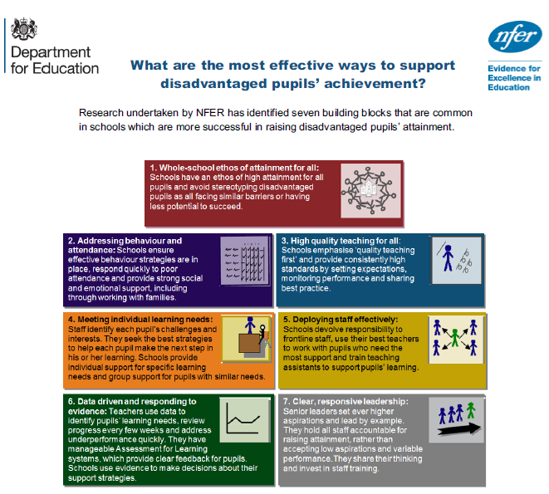
Target 4
(Funded Trips, Better Living Team, Milk, Uniform, Counselling, Bespoke Needs )

Target 5
(Effective use of TA’s)
Target 3
(High Quality Intervention Teacher. Specialist Subject Teachers & CPD)

Target 2
(Breakfast Club, Attendance Tracking, CPOMS & Pastoral Team
Target 7
(Tracking Groups in all subjects, Performance Management & Raising attainment/Pupil Progress Meetings)

Target 6
(Boys, MA, Booster Sessions & Edukey)
Target 1
(Training & Pastoral Rewards)

