2020-2021
A Guide to
Reading
at
Carlinghow Academy

This document outlines the expectations of how we teach and monitor Reading at Carlinghow: progression across year groups and consistency across school. It should be read in conjunction with the school’s Reading Statement on the website.

Phonics and Guided Reading
- A Love of Reading
- RWI
- Teaching Reading: Reading Skills
- 1:1 Reading
- Assessment
- Monitoring
- Intervention
- Home Reading
- Resources

Promoting a love of reading
- Children should be read to DAILY.
- All classes must have a reading display. This should showcase texts that have been read over the year (including key vocabulary), a reading rewards display and your current reading skill (KS1 dogs/KS2 VIPERS).
- All classes must have a reading area.
- All children should have a signed library agreement and all classes are timetabled to visit the library every week.
- Buddy reading will take place at least once every half term.
- World Book Day will be celebrated every year.
- Parents are invited into school for shared reading.

Consider:
- Do children have choice about what they read?
- Do children have an opportunity to share books with their friends?
- Are children ‘comfortable and relaxed’ when enjoying reading for pleasure?
- How do children get to find out about new books/authors?
- How do you broaden children’s reading interests?
- Do you have a range of high quality fiction, non-fiction and poetry texts available in class?
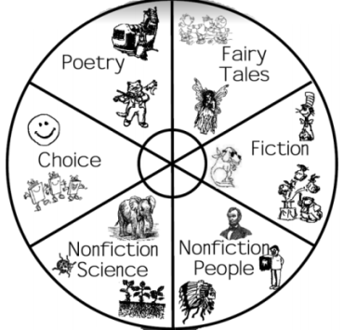
Ideas for promoting reading:
- Drama/role-play
- Story sacks
- Shared book reviews
- Reading challenges in class
- Reading bingo
- Reading around the world
- ‘Spin the wheel’ to choose a new genre/author

RWI Groups for EYs and KS1

Set 1  A & B | Set 1  C | Ditty | Red | Green | Purple | Pink | Orange | Yellow | Blue | Grey | LLG
Reception Progress |  |  |  |  |  | Y1 Progress |  |  | Y2 Progress
On Track Progress through the RWI colours: **guide only

RWI lessons run Mon – Fri and they incorporate weekly spellings set by the group leader
Mon – Thurs: 8.45-9.20 and Friday: 9.25 – 9.45

Autumn Term:
Reception: baseline and teach Set 1 sounds
Y1 and Y2 children are set in ability groups
Y2 comprehension group

Spring and Summer Term:
Children regrouped
Reception children are set with Y1 and Y2 in ability groups
Expand Y2 reading comprehension group

** Children entering Y2 who are working securely at blue or above will form a comprehension focus group looking at more challenging texts, e.g. chapter books

Spelling words are to be sent home every Monday with the red and speedy green RWI words copied onto the reverse side (these may be the same words over two weeks).

All staff running a RWI group must have a file containing:
- A RWI timetable
- A half term planning sheet
- A record of weekly spelling scores/words
- A 1:1 reading record for every child in your group
- A red word tracker for every child
- The current assessment for every child
- A copy of the red and green words
All staff must follow the RWI timetable, including the ‘hold a sentence’ activity. When children are learning green words, they should always find ‘special friends’ first, segment the sounds and then blend the word. See RWI Handbook 1 and 2 for further guidance and lesson plans.
Resources can be found on the staff server: English; Phonics; RWI and the school has a subscription to Oxford Owl.

DISCRETE TEACHING OF READING SKILLS

ACTIVATING PRIOR KNOWLEDGE
What do children already know about the story they are going to be reading/listening to?
Could you use some images/videos about the content to support children’s understanding?
Could a non-fiction text support a fiction text?
Is there any key vocabulary children need to know? Have children read books by this author before?

YEAR ONE
Autumn One | Autumn Two | Spring One | Spring Two | Summer One | Summer Two
Prediction  Questioning | Sequencing  Retrieval | Retrieval  Inference | Inference  NF Features | Summarising  Dictionary Skills | Poetry  Dictionary Skills
Clarifying will focus on vocabulary development which should be an integral skill during all shared/guided reading.

YEAR TWO
Autumn One | Autumn Two | Spring One | Spring Two | Summer One | Summer Two
Prediction  Questioning  Dictionary Skills | Sequencing  Retrieval  Dictionary Skills | Retrieval  Inference  NF Features | Practice and review all skills  Fluency | Practice and review all skills  NF Features | Summarising  Fluency  Poetry
Clarifying will focus on vocabulary development which should be an integral skill during all shared/guided reading.

KS2
Autumn One | Autumn Two | Spring One | Spring Two | Summer One | Summer Two
Prediction  Fluency  Summarising | Clarifying  Retrieval  Dictionary Skills | Inference  NF Features | Poetry  Questioning | Inference (characterisation)  Dictionary Skills | NF Features  Practice and review all skills

YEAR SIX
Autumn One | Autumn Two | Spring One | Spring Two | Summer One | Summer Two
Prediction  Fluency  Questioning | Retrieval  Inference  Clarifying | Summarising  Inference  Characterisation | Practice and review all skills | Practice and review all skills | Poetry
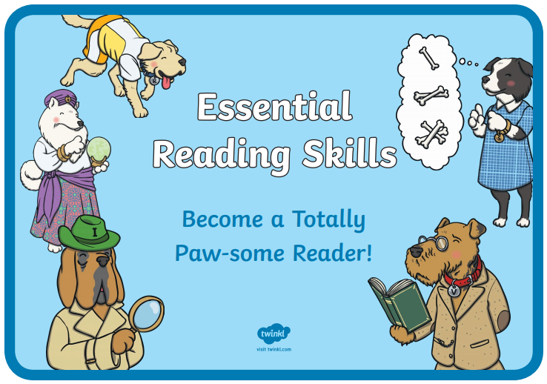
In KS1, children will meet the totally ‘Paw-some’ gang!
Rex Retriever Iggy Inference
Prediction Pip Sequencing Suki
Victor Vocabulary

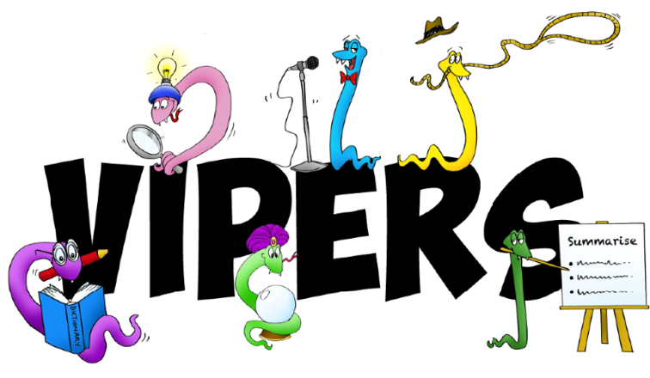
In KS2, children will meet the VIPERS (with the addition of the clarifying cobra and queen snake questioner)!

Reading Timetables
KS1
Monday | Tuesday | Wednesday | Thursday | Friday
RWI | RWI | RWI | RWI | RWI  1 hour reading skill lesson based on a weekly shared class text  (Linked to the Paw-some Gang)
RWI lessons must follow the teaching sequence (which includes a focus on the spelling and reading of red words and ‘hold a sentence’) – please see timetable.

Children need to be assessed every half term and the on-going reading tracker should be saved on the server by the Monday of the final week of each half term so children can be regrouped accordingly.
There is an expectation that children will be read to daily: this may be in addition to the class text.
Reading skills will also be developed throughout your text base English unit; particularly during the ‘read/respond’ phase. Suggested activities include role-play and drama, highlighting texts, thoughts/feeling maps, feeling graphs and comprehension questions linked to the reading dogs.

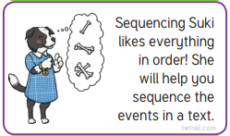
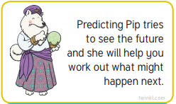

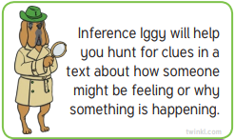

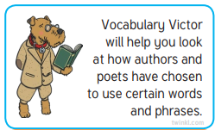
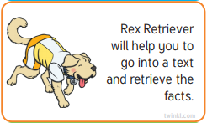

Take every opportunity to extend children’s vocabulary. Include new vocabulary on the working wall and discuss the meaning of new words as they occur in texts.

KS2

Over a half term, the expectations are:
Weekly explicit teaching of a reading skill
1 weekly 30min lesson discretely teaching the reading skill identified on the timetable. This may or may not be linked to your class text.
1x VIPER chapter sheets
VIPER sheets should be used to explore your class text; subsequently improving children’s writing.

Children will need to be taught how to use these sheets and the whole class should discuss their answers at the end of each session. This will allow an opportunity for quality discussion and for teacher modelling...

Which prediction is better? Why?
Who else agrees that was an important event?
Who disagrees with…?
What evidence from the text supports your answer?
Let’s read around the word… can we clarify it? Who can use it in another context?

A VIPER sheet should take a lesson for children to complete. Children should be given the opportunity to partner read and discuss the chapter(s) or the teacher can model reading aloud to the children as they follow in their own text.

As children are completing their sheets independently, in partners or with an adult, the teacher/TAS will have an opportunity to listen to 1:1 readers and complete their 1:1 records.
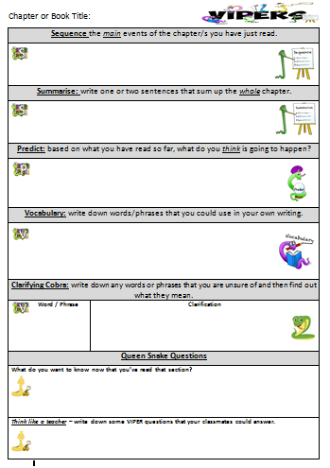

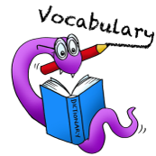
Weekly Vocabulary
Teach 1x 30min vocabulary lesson per week.
Words should be selected:
- From the class text
- From the working wall (words children will be encouraged to use in their own writing)
- From the spelling scheme, e.g. word explosions to explore the meaning of suffixes/prefixes
- From the class topic

Images are fantastic for developing vocabulary and you may choose a particular focus, e.g. using fronted adverbial phrases, expanded noun phrases… This is also a great starter for English lessons.

You can also change the focus on the vocabulary section of the VIPER sheet, e.g. find all of the alternative words for said, find prepositional phrases the author has used…

Words should be unfamiliar and challenging and children should be given the opportunity to explore their meaning and apply them. This lesson can also be used for teaching dictionary/thesaurus skills.
3x Nelson Comprehension
These resources should be used to teach children – not assess them.

Partner reading of the text followed by a class discussion of unfamiliar vocabulary and an opportunity to clarify. The teacher should then model the reading of the text as the children follow.

Children should then have a full session to answer the comprehension questions (could be done as partner or independent work).

At the end of the session, the children should purple pen mark their work as a whole class: discussing the answers and showing where they found their evidence. Discuss the style of questions to help children understand what skills they need to use, and explore whether more than one answer can be correct.

As children are completing their comprehension work independently, in partners or with an adult, the teacher/TAs will have an opportunity to listen to 1:1 readers and complete their 1:1 records.

Note: texts should be differentiated for the different abilities of readers in the class.
Mixed ability partners can also be beneficial.

Fluency Skills
In the Autumn term, children should be taught how to use the fluency bookmarks for self and peer assessing fluency. Introduce children to these pictures and what they mean. Throughout the year, children should be given lots of opportunities for partner reading to develop their fluency skills and children should engage in conversations about specific fluency skills when an adult listens to them during 1:1 reading time or when the teacher is completing the fluency rubric.
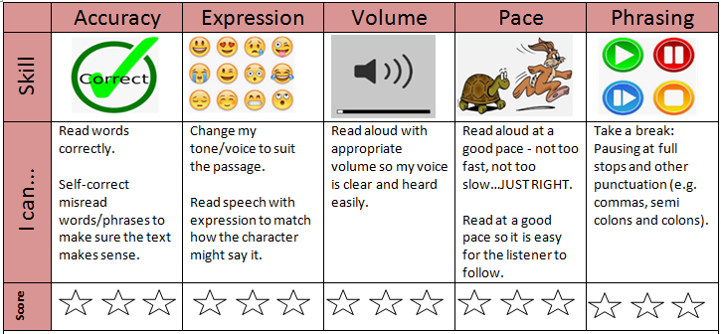

One to One Reading in KS1:
Teachers should hear every child read at least once per term and a colour band running record should be completed (sample texts provided).

Please ensure that children are on an appropriate colour band to match their reading level: children should be able to read their home reading books with at least 96% accuracy.

Please keep a frequency record of how often children have read in school and identify your target readers that will be listened to at least 1x/week (priority should be given to children working below ARE/who do not read at home).

Sample RWI 1:1 recording proforma

oi

Teacher 1:1 recording proforma

For a running record, you can simply photocopy a page from a colour band book.

Record errors and work out children’s accuracy and SC (self-correction) rate.

MSV: meaning, structure or visual cues.
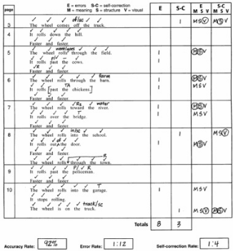
Sample Running Record

One to One Reading in KS2:

Every child should have a fluency rubric in the reading file and it is expected that the class teacher will update this once/term. On the reverse should be a child’s 1:1 teacher reading record.

Please use a different colour to highlight each assessment point and on the teacher record on the reverse, make a note of the child’s colour band and whether you have moved them on since their last assessment.

Please keep a frequency record of how often children have read in school and identify your target readers that will be listened to at least 1x/week (priority should be given to children working below ARE/who do not read at home).

Teachers and TAs should endeavour to listen to children read while children are completing independent comprehension work.
Reading Records

- Discuss what area of fluency the child is working on and score them according to the rubric. Children can identify this on the ‘child-friendly’ rubric bookmark.

- Echo reading: model back part of the text to help children improve their reading, e.g. demonstrating where to pause, or use of expression…

- Record brief/specific comments. Be aware that if every comment says, ‘lovely reading, read well…’ it would imply the child is not being challenged.

- Review gaps in subsequent sessions, e.g. if a child did not know the ‘ai’ sound, start the following session by looking at some words with ‘ai’.

- Ensure you monitor children’s progress through the colour bands and move them on when appropriate.
Reading Record with Fluency Rubric
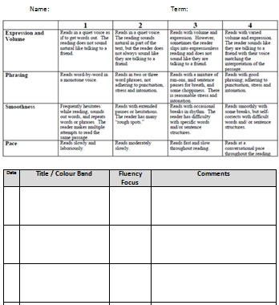

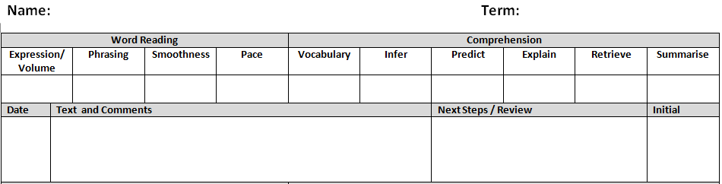
Teacher Assessment reading records (to be completed half-termly)

Teacher Reading Records

- Use tally marks when a child has shown a skill.

- Make comments linked to specific skills.

Reading Assessment:
Class teachers will ensure a RWI assessment and red word tracker is completed for every child in YR, Y1 and Y2 each half term and updated on the class’ on-going reading tracker. Some children working below ARE in Y3 and Y4 will also be tracked in this way.
Autumn 1 | Autumn 2 | Spring 1 | Spring 2 | Summer 1 | Summer 2
Assessment 1 | Assessment 2 | Assessment 3 | Assessment 1 | Assessment 2 | Assessment 3

Please continue children’s assessments from the previous colour of where they got to in their last assessment. E.g. if a child is working at blue, please start their next assessment from yellow.
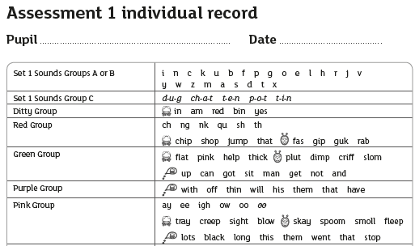

Teachers must use the RWI Assessment Criteria guide for deciding children’s levels. All assessment information can be found on the server and in the Reading Leader handbooks. For example:
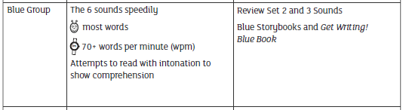

On-Going Reading Assessment:

Half termly Rising Star comprehension assessments

- Children who are working at ARE should start the year on their age-appropriate Rising Star test, e.g. a child who starts Y4 as 3S on target tracker should do the Y4 Autumn 1 Rising Star Assessment at the end of Autumn 1.
- For children working above/below ARE, please continue progressing children through the assessments (bearing in mind children who need to make rapid progress).
- When completing your on-going assessment record, please record which RS test children did, their overall score and their scores for F, NF and P (fiction, non-fiction and poetry).
- If you have children who are making below expected progress, you should use the RS question analysis to identify what gaps they have, e.g. inference style questions.

.

Use these records to moderate your own judgements and to monitor progress.

Monitoring:

- Reading response books will be included in English scrutinies.
- KS1 work can be kept in English books and should include discrete skill teaching, vocabulary work and whole class comprehension work. Y2 children working in the comprehension group should use reading response books for their work.
- KS2 books should have discrete skill teaching, 1x VIPER sheets, 3x Nelson Comprehension Reading Comprehension, vocabulary work and fluency self/peer assessments.

- Reading files will be collected every term to monitor home/school reading.

- On-going reading trackers will be used to quality assure judgements and monitor progress.

- Pupil interviews (including listening to children read their home reading book/Ofsted questions)

Note: Y2 reading is moderated in the LA moderation cycle. Reading records and comprehension work should be provided as evidence to support teacher judgements.

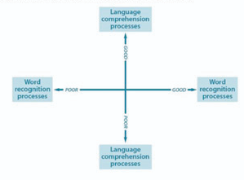

Interventions:

Use the reading quadrant to identify children’s strengths and weaknesses and what intervention may be needed.

- Pre-teach vocabulary / prior knowledge
- 1:1 reading (target gaps in fluency using the fluency rubric)
- Continue RWI interventions for children in Y3 and Y4 who have not reached LLG
- 1:1 teach and monitor first 200 HFWs, red words and Y1/2 CEW sight words for SEN children

It is also useful to consider the reading quadrant when grouping children, e.g. partner a confident decoder/poor comp reader with a child who has weaker decoding skills but good comprehension.

Home Reading
Home reading books should be pitched at a level that the child is able to read confidently and fluently (accuracy rate of 96%+) to enable them to read for pleasure and experience success!
We want children to enjoy sharing books at home with their families and to be able to show off their improving reading skills!
- Nursery: borrow books from class.

- Reception: borrow books from class and all children will start taking colour band books home from A2 (some children will require lilac or word books, while many will be ready to start at pink/ditty level or above). They should also take RWI speedy green words/red words home every Monday and additional phonics homework can be sent home linked to what children have been learning in class.

- KS1: change books at least 3x/week and RWI speedy words/red words are sent home with spelling words every Monday.
- KS2: reading logs are checked at least 2x/week but children may need longer to read their books.
Free Readers:
KS1: children who have competed lime.
KS2: children who have completed burgundy.
Please ensure that more able readers are given age-appropriate texts.

Reading Logs
A reading log (with instructions) will be provided to every child in school. If a child loses their reading log, a card replacement reading log will be sent home.
Reading logs should be promoted and checked weekly on book changing days. TA’s to sign reading logs when seen and when children progress to the next colour band, please put a colour band progression sticker in their reading log to let parents know.
Children receive a house point every time they read at home.
Once a child has completed 2 pages of their reading log, they will receive a certificate in praise assembly (class teacher to print): bronze, silver, gold and then platinum. Please keep completed reading logs/cards in your reading file.
Records for frequency of home reading must be kept.
Please monitor the return of books. If a child hasn’t returned their book within a week, please send home a book replacement slip. Once the book has been returned/the fee paid, a new book and reading log should be sent home. If books are still not being returned, please speak directly to parents/carers.

Reading Resources

- RWI books (include teacher guides and flashcards). Please keep all resources from these packs together.
- Colour band books
- VIPERS on the server
- Twinkl reading dogs (including 60 second reads)
- Oxford Owl (online resource linked to phonics)
- Nelson Comprehension
- Rising Star reading assessments
- Past SATs papers
- Twinkl (reading comprehension)
- Espresso (phonics games etc…)
