2020-2021

A Guide to
English
at
Carlinghow Academy

This document outlines the expectations of how we teach English at Carlinghow: progression across year groups and consistency across school.

Handwriting
- Progression
- Pen Pals
Spelling
- Progression
- Resources
- Groups
- Assessment
- Non-negotiables
Writing
- Differentiation
- Planning a Text Based Unit
- Think Pinks/ Next Steps

Handwriting

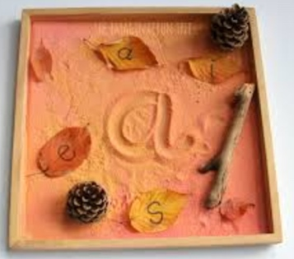
Nursery:
- Mark making activities (including texture trays, foam…)
- Funky finger challenges
- Dough gym or Write Dance
- Weekly name writing (focus on target letters in name)
- Records of children’s pencil grip

Reception:
- Daily name writing until children can write their names independently (correct formation)
- Letter formation taught in RWI phonics sessions
- At least one handwriting lesson/week
- Letter formation modelled and practised during English focus tasks (children working at tables)

Year One:
- Daily handwriting following the Pen Pals scheme
- Once children can form all letters correctly, they should start to learn joins following the Y2 Pen Pals
- Include Y1 CEW spellings that have the letters being taught

Year Two:
- Daily handwriting following the Pen Pals scheme
- Children will start learning joins in the Autumn term
- Include Y2 CEW spellings that have the joins being taught
- Intervention for children not forming letters correctly

KS2:
- Handwriting lessons follow the Pen Pals scheme
- Autumn 1: daily handwriting for the first 3 weeks to set expectations and then 3x/week thereafter for Y3/4 and 2x/week thereafter for Y5/6
- Pen licenses may be awarded once handwriting is joined, neat, legible and evenly sized.
- Children with pen licenses will use biro pens in their books and handwriting pens for publishing; some children may prefer to continue writing in pencil.
- Children who have achieved their pen licences can practice copying extended text (e.g. short poems) to improve their writing stamina, speed and fluency – children can be timed
- Daily handwriting practise is needed for any children not joining
- Intervention for children not forming letters correctly

Correct starting points and correct formation should always be the priority as well as ensuring children are sitting comfortably and correctly at a table with the correct pencil grip.

Guidance for using the Pen Pals Scheme

- Warm up with the Pen Pals gym
- Click on the teaching tab to watch an animation of the correct letter formation/joins
- Children practise the joins in their book – adults should oversee correct formation before moving on
- Click on the practice tab to bring up a word bank of words for children to practice applying the joins
- Use the Pen Pals handbooks or worksheets for extension/differentiation

- Remind children of ascenders, descenders and evenly sized letters and spacing

- Children should self and peer assess their handwriting

- An adult should write a sample letter/join using pink pen in children’s books if extra support is needed and some children may need to trace over highlighter, ensuring they are using the correct starting point.

- See the guide below and the teacher’s manual to ensure the correct joins are being taught: some letters don’t join in the Pen Pals scheme

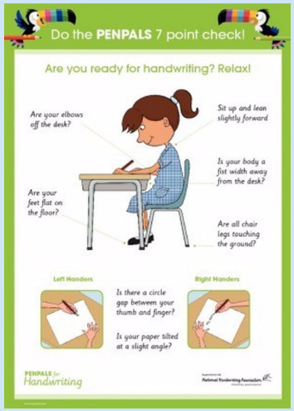
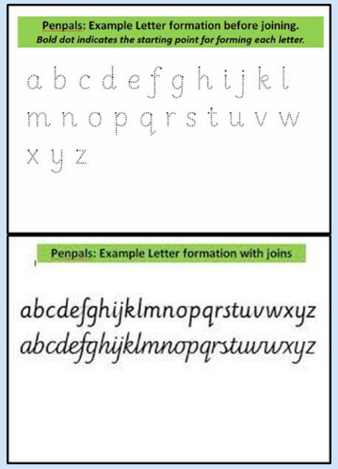

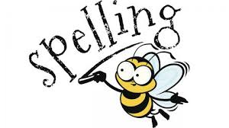
Spelling
Nursery:
- Children are taught rhyme and alliteration through phase one phonics teaching
- Adults will regularly model orally segmenting and blending the sounds in words
- Children will begin to orally blend and segment the sounds in spoken words

Reception:
- The first 100 HFWs should be a focus during modelled writing and English focus tasks – word mats should be available in provision
- Individual records should be kept of the 100 HFWs children can read and spell
- In the summer term, children will take home 5 HFWs to learn for a weekly test
- The spelling of red and green words will be taught explicitly following the RWI timetable and teaching strategies: Fred fingers, red rhythms and sound buttons
- Autumn Term: daily phonics introducing set 1 and set 2 sounds following RWI
- Spring and Summer Term: children will be set in RWI groups with KS1 children: this will be in addition to daily phonics sessions in class

KS1 and KS2

Spelling Resources
All children have:
- A spelling bookmark kept in the back of their English book. These are for age-appropriate individual ‘nagging’ words that children spell incorrectly in their writing.

- Word mats should be readily available in table ‘goody boxes’
- Twinkl spelling rule teaching power points and activities, e.g. loop games, word searches and crosswords etc…
- Spelling Shed
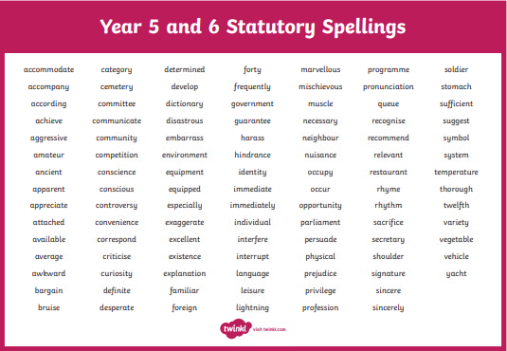
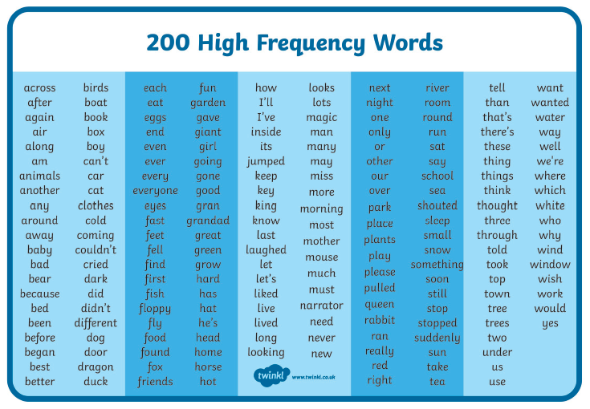

Spelling Tests

- Weekly spelling words are sent home every Monday
- Children are tested every Friday
- Words are set using RWI/Babcock No Nonsense Spelling scheme
- KS1 follow the RWI phonics teaching sequence of green and red words
- Most Y2 groups and KS2 follow the teaching sequence from the Babcock No Nonsense Spelling scheme
- Children will take home between 5 and 20 words to learn each week (depending on ability)
- Spelling homework proformas can be found the server (English; spelling; homework sheets)
- There will be a set number of spelling rule words and CEWs set each week
- A record of children’s weekly spelling scores should be kept
- Children should self/peer mark their tests (an adult to check)
- Corrections are written in pink so children can copy them onto their new sheet the following Monday

Spelling Groups

KS1:
Children are regrouped every half term (same groupings as RWI). As a result, spelling words may need to be differentiated in your group for less/more able spellers as the groups are based on children’s phonics reading assessments.

KS2:
Please monitor any children who are consistently scoring low marks or 100% in their weekly tests: you could differentiate their spellings by setting them less/more words.

Spelling Assessment

All children from Y1 to Y6 are assessed on the spelling of CEWs for their year group (note: some children will be working below/above).
- Scores and words spelled correctly are marked on children’s individual spelling records: these are inside the front cover of their English book (see below)
- A copy of children’s words to learn should be shared at parents’ meetings
- Scores are recorded on a spreadsheet and saved on the server for the English Coordinator

Children’s record sheets can be found on the server: English; spelling; children’s record sheets

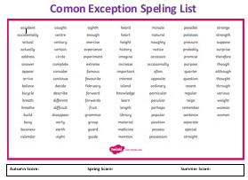
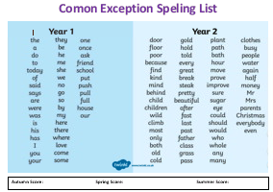

Note: please test words across the CEW spelling lists so that children aren’t consecutively spellings words with the same pattern/words in alphabetical order.

Whole Class Teaching

Year One:
- In addition to RWI spelling groups, children should do at least three whole class spelling focus sessions/week. Two of these sessions should be to teach the spelling of ‘green’ words with digraphs and one session should focus on CEW/HFW spellings.
- Spelling rules should be introduced in Summer 1 (following the NC)
- Phonics intervention for identified children

Year Two:
- At least three whole class spelling focus sessions/week. Two of these sessions should follow the Babcock No-Nonsense scheme and one session should focus on spelling CEWs.
- Phonics intervention for children who didn’t pass the phonics screen test in Y1 should start in the Autumn Term.

KS2:
Select a whole class spelling rule each week following the teaching sequence of the appropriate year group from Babcock. This should be displayed on your working wall.
Here are some examples of Twinkl spelling rule posters:
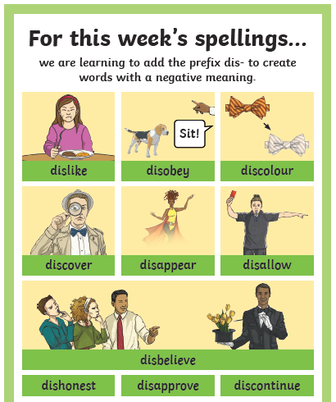
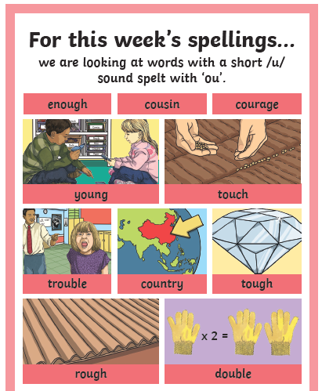

Non-negotiables

In KS2, the following KS1 spelling rules must be reviewed at the start of every term and they should be identified in marking.

Rules for adding suffixes ‘ed’ and ‘ing’
If it is a short vowel, double the consonant.
If there is already a double consonant, just add the suffix.
If it has a long vowel sound just add the suffix.
If it ends in ‘e’, drop the ‘e’ and add the suffix.

Rules for plurals
es, s or ies

Adding suffixes to words ending in y
‘Change the y to an i.’

Spelling the suffixes: ‘ful’, ‘ment’, ‘less’ and ‘ly’

Contractions

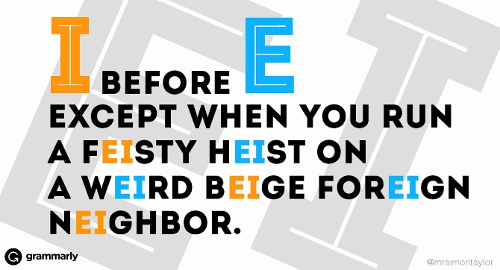

Writing
Nursery:
- Working towards all children being able to write their name by the end of nursery
- Correct pencil grip
- A range of opportunities to develop children’s fine and gross motor movements
- Writing (mark-making) for different purposes, e.g. shopping lists, labels, doctor’s notes etc… and observations will be uploaded to Seesaw

Reception:
- Two English focus task sessions per week.
- English learning journeys (in books) to include a range of children’s independent and adult supported work: focus tasks, work completed in provision, photos of provision, phonics work…

Year One:
- Children to copy the full date (inside the first line).
- All work to have an L.O. written as an ‘I can’ statement.
- All pieces of writing should have a SC table (progressive over the year and can be differentiated).
- The learning journey over a topic might include role-play/drama work, first hand experiences, modelled/guided writing, sentence/picture sequencing, story maps, sentence level work with a specific focus (e.g. use ‘and’ to join my sentences) and independent writing tasks.
- Children are taught to use purple pen to edit their work (begin with HFW spelling errors and letter formation).
- Photos, annotated by the children, should be included.
- A range of purposeful writing opportunities should be provided; however please remember the year one objectives should be the focus of your teaching, not text type features.

Year Two: same as above
- Children must be given time to edit their work.
- Please be aware that Y2 writing assessment requires you to evidence all outcomes on the Y2 interim writing assessment framework. From the Spring Term, you will need 6 pieces of writing per child which show how they have achieved these objectives across their pieces of work. The pieces used for each child can vary to showcase individual children’s best work.
- Errors identified by a teacher do not provide evidence for children’s writing assessments.
Note: when teaching exclamation sentences, children must be taught that they start with the words what or how and they must include a verb. What an amazing day we had!

Example SC grid:

KS2: (building on KS1)
- Learning journeys should include WAGOLLs and a unit should build up to a piece of writing (e.g. exploring character and setting before writing their own narrative).
- SPAG work should link directly to the text type children will be writing, e.g in Y3 children should learn how to use inverted commas before writing a narrative so they can include correctly punctuated speech…
- Children must be pulled up for KS1 SPAG errors. Punctuating sentences correctly with capital letters and full stops must be taught as a priority before introducing further types of punctuation.
- Quick, snappy SPAG starters should be included in lessons.
- Children need the opportunity to write complete pieces which are structured correctly. All year groups must write at least one complete short story.

Writing Assessment

Writing Assessment Tick sheets
Every child will have an assessment sheet. These should be kept in a file and will be requested for English scrutiny and moderation events across the year.
These should be updated at least 4 times over a term and used when making your end of term teacher judgements on target tracker.

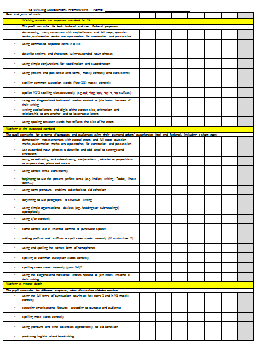

Children also have a writing target foldout on the inside cover of their English book. Targets must be achievable and specific and they should be referred to and marked off regularly.
Example Targets:
- Use a comma to mark fronted adverbial phrases
- Use propositions to extend my sentences
- Vary my sentence openers by starting with a subordinate clause
- Punctuate my first 2 sentences correctly with capital letters and full stops.

Moderation

Moderation staff meetings will be held across the year as well as cluster moderation events.

Writing exemplification materials for the end of KS1 and KS2 can be found on the DfE website and there are further exemplification documents on the staff server.

Please endeavour to moderate and agree a low, middle and high ability child’s writing with a colleague, your phase leader or the English coordinator before making your end of term judgements.

Differentiation in English
- Different learning objectives given for the same writing task, e.g. in Y2, a less able child’s L.O could be, I can use ‘and’ to join two sentences, while a more able child’s L.O could be, ‘I can use a range of conjunctions to extend my sentences’.
- Differentiated success criteria – children should refer to these as their writing targets.
- Children’s individual writing targets (flap on the inside cover of English books)
- Differentiation by outcome for writing assessment pieces.
- Differentiated tasks, e.g. one group might be working on labelling adjectives on a picture while another group could be writing expanded noun phrases.
- Level of support: scaffolding, guided/modelled writing etc…
- Slow writing tasks – children asked to include different features step by step.
- Differentiated writing resources, e.g. coloured paper, larger lines, spelling lists, pencil grips, typing, images, sentence starters…

Planning a Text Based Unit
There is a Long Term English plan in place; however this is a working document and is still being updated to reflect what is being taught, ensuring variation and progression across every year group.
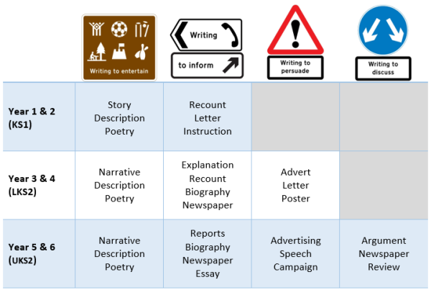

Text Type
Audience
Purpose

Medium Term Planning

When completing your medium term plan, consider:
- What opportunities are there for ‘talk for writing’, drama/role-play…?
- What will be the main text type that you need to teach the features for?
- What opportunities will children have to explore and deconstruct texts?
- What have children covered previously?
- What objectives from the assessment sheets are appropriate to the text type?
- What are children working towards/building up to?
- Which objectives from the NC have not yet been covered?
- What planning opportunities will you give children?
- What resources will you need?
- What will you need on your working wall to support children’s writing?
- Will children revisit their work over a number of days?
- Have you planned enough time for children to draft, redraft, edit and publish a complete piece of work?
- Do children have a clear purpose and audience for their writing?

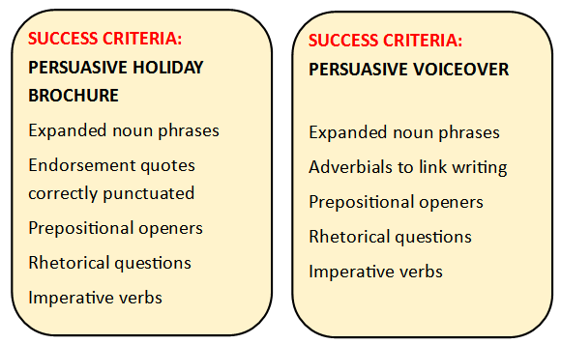

Here are some examples of how SPAG could link to a writing unit.

What have you already covered?

What needs to be covered?

We should always be aiming for quality over quantity.

Think Pinks and Next Steps
Ensure that next steps link to the learning objective, success criteria targets (which should be linked to the assessment sheets) or individual nagging targets.

Children should be given regular opportunities to edit their own (and others’) work with increasing independence: Please refer to the editing process in the supporting English Guide to see how teacher scaffolds for editing should be gradually removed as the year progresses.

At the beginning of the year, think pinks can be closely linked to the editing process as you support children to identify errors in their work. For example, teacher identified spellings where the teacher has underlined a word for children to find in a dictionary/on a word mat or a ‘g’ next to a word which is grammatically incorrect. Please be aware however that any corrections resulting from teacher identified errors cannot provide evidence towards children’s assessments.
Don’t expect children to complete a whole piece of writing before they edit. Use editing pit stops – you could model a common misconception/error and remind children that good writers reread their work.

It is good to see a balance of think pinks – some that are linked to editing and some that provide further challenge for children. Here are some examples:

- Correct letter formation (including ascenders and descenders).

- Practice spellings rules, for example, if a child had written danceing you could ask them to explain the rule for adding ‘ing’ to a word ending in ‘e’ and then ask them to add ‘ing’ to the words shake, slice etc…

- Ask children to identify an example of a SC target within their work, e.g. what is your best expanded noun phrase? or, underline an example where you have used a fronted adverbial phrase.

- Can you think of a different adjective to describe…?

- Why have you used the adjective/adverb/relative clause __________?

- Can you find somewhere that you could include a relative clause?

